Visual Interpretation and Analysis of

HPC Nanostructure Models using Shared Virtual Environments†

Ronald D. Kriz
Department of Engineering Science and Mechanics, Norris Hall
Virginia Polytechnic Institute and State University, Blacksburg, VA 24061
rkriz@vt.edu

Diana Farkas
Department of Materials Science and Engineering, Holden Hall
Virginia Polytechnic Institute and State University, Blacksburg, VA 24061
diana@vt.edu

Andrew A. Ray
Department of Computer Science, McBryde Hall,
Virginia Polytechnic Institute and State University Blacksburg, VA 24061
anray2@vt.edu

John Kelso
Department of Computer Science, McBryde Hall,
Virginia Polytechnic Institute and State University Blacksburg, VA 24061
kelso@vt.edu

Raymond E. Flanery, Jr.
Advanced Visualization Research Center, Oak Ridge National Labs
PO 2008, Bldg 6012, Oak Ridge, TN 37831-6367
flaneryrejr@ornl.gov

Keywords: Virtual reality, nano-structures

Abstract
The advent of high performance computers (HPC) has allowed materials researchers to model large three-dimensional (3D) nanostructures. Properties associated with these 3D structures can be sufficiently complex where researchers can benefit from immersive virtual environments (VEs) in their analysis and interpretation of HPC model results. Because immersive VEs are expensive and not as convenient compared to the researcher’s desktop computers, desktop VE-simulators have become important for day-to-day routine analysis. Recently desktop computer graphic cards have significantly improved and consequently emphasized the use of desktop VE-simulators when analyzing large structures. In spite of these advances at the desktop, immersive VEs have continued to prove invaluable in special cases. Although both immersive VEs and desktop VE-simulators are useful, analysis is typically limited to a single researcher. With high-speed networks, immersive VEs and desktop VE-simulators can be combined into a share collaborative workspace. Shared VE applications were created using a new API called DIVERSE. To foster collaborative development the DIVERSE API was licensed GNU-GPL/LGPL. These collaborative VE applications were designed to enhance researchers’ interpretation and analysis of HPC results.

BACKGROUND
For several years now material researchers have used commercial graphical tools at their desktop computers to interpret and analyze properties associated with large three-dimensional (3D) nanostructures predicted by their high performance computer (HPC) models. Many 3D nanostructures that can be visually interpreted and analyzed at desktop computers can also be analyzed and interpreted in immersive virtual environments (VEs) such as a CAVE™. In some cases immersive VEs can be more insightful from the researchers’ viewpoint. The CAVE is a multi-person, room-sized, high-resolution, 3D video and audio environment. In the current configuration, graphics are rear projected in stereo onto three walls and the floor, and viewed with stereo glasses, see Figure 1.
Because it is more convenient for researchers to work at their desktop computers, there was a need to extend visual analysis done at the desktop to more insightful immersive VEs when necessary. Hence VE applications were developed that scaled from the desktop computer to an immersive VE such as a CAVE. These VE applications were also networked together into a collaborative working environment, which enhanced researchers’ interpretation and analysis. Here we summarize the development and use of these collaborative VE applications.

CREATION OF APPLICATIONS
Creation of nanostructure visualization applications were based on two different software APIs (Application Programming Interfaces): 1) the CAVE-libraries which were created at the Electronic Visualization Laboratory of the University of Illinois and 2) DIVERSE which was created at the University Visualization and Animation Group at Virginia Tech.

CAVE-Libraries API
These libraries were developed when the CAVE itself was first created. In collaboration with NCSA, Atomview, CCC, and CCC_atom were applications developed using the CAVE-Libraries. These applications were funded as tasks on two separate grants: 1) the NSF ARI equipment acquisition grant to build a CAVE at Virginia Tech and 2) the NSF Partnership in Advanced Computational Infrastructure (PACI), Team-C “Data Collaboration”.

Atomview
Atomview is a SGI-Performer based VE application, which runs both at the desktop as well as in the CAVE [1]. This application was developed for Professor Diana Farkas in the Department of Materials Science and Engineering at Virginia Tech. Professor Farkas routinely used Atomview to visually interpret and analysis her 3D nanostructures HPC model predictions. Results were summarized in the NCSA Access magazine [2].
Atomview provided visual interpretation and analysis of nanostructure HPC model results that resulted in six journal publications listed in the final National Science Foundation ARI- report [3]. Two examples are shown: 1) Mode-I crack propagation along a B2 NiAl grain boundary and 2) creation of stacking faults along a Ni (FCC) grain boundary.
Figure 2 shows a B2 NiAl inter-metallic where the researcher is using the desktop CAVE-simulator. With this desktop VE-simulator the researcher can observe dislocations emanating from the crack tip as the mode-I crack propagates along a grain boundary. Time animations show that crack-tip dislocations result in a larger crack tip radius, which can explain higher fracture strength.
Figure 3 shows the formation of stacking faults along a Ni (FCC-structure) grain boundary. This time-sequence figure shows the emission of a partial dislocation from a Ni grain boundary where only atoms at the grain boundary are shown (gray). The Ni atoms associated with lower energy levels in the interior of the grain have been removed. This allows the researcher an unobstructed view of the atoms that exist at a higher energy state, which is where the formation of stacking faults occurs. The movement of partial dislocation inside the grain creates a stacking fault, which is seen as an increase in the number of red atoms. Although this property can be shown on a desktop VE, this particular animated example is better observed in an immersive VE such as a CAVE. Although several researchers can observe this phenomena in the CAVE, Atomview is not designed to be used by multiple observers.
Collaborative CAVE Console (CCC)
Development of CCC was largely motivated by a postmortem analysis of the Explore Tele-Immersion project at the 1998 Supercomputing conference. As a participant, Mr. Kevin Curry chose to improve on this experience by extending the Electronic Visualization Laboratory (EVL) Limbo software to include “collaborative awareness tools”. Results of this research are published in Mr. Curry’s Master’s Thesis [4]. The CCC Web site is given in [5].
The movement and presence of other remote-site participants are shown as “avatars”, see Figure 4. CCC adds three tools to support participant awareness: 1) Participant List, 2) 3D radar, and 3) 2D radar shown in Figure 5.
The Participant List displays a list of names of the participants that are present in the world, plus the distance to each avatar from one's current position. Every participant’s name is colored differently, and the same color is used in the radars to represent the same user.
 The 3D radar is an egocentric representation of the avatars in a shared VE, where each participant is at the center of their radar, and each blip represents other participants in the shared VE. Color of each blip is the same as the color of the participant's name in the Participant List. Position of the avatar representations in the radar is continuously updated as avatars move around the shared VE in any direction.
 The 2D radar is a flat representation of the 3D radar corresponding to a projection on a horizontal plane of all the avatar positions. We added the 2D radar because many people found it easier to understand than the 3D radar, especially because being a flat view, perspective does not distort the representation of distance as avatars move farther away from the user.
These and other CCC features are listed in the menus shown in Figure 6 where a CCC session can be recorded and played back and participants can tether or share views with other participants.

CCC_atom
CCC_atom is the merging of the CAVE Collaborative Console (CCC) with Atomview. The combination of these two applications allows multiple users to view, interpret, and analyze 3D nanostructures with collaborative tools available within the CCC, see Figure 7. Specifically CCC_atom was designed to enhance scientific collaboration between Professor Farkas at Virginia Tech and Dr. Swygenhoven at the Paul Scherrer Institute in Switzerland. The CCC_atom Web site [6], provides download access, as well as instructions on installations.

DIVERSE API
DIVERSE was developed at Virginia Tech in collaboration with the National Institute for Standards and Technology (NIST) [7]. DIVERSE was designed with a common user interface to interactive graphics and/or VE programs. Using DIVERSE the same program can be run on CAVE, RAVE, Immersa-Desk, HMD (head mounted display), desktop, and laptop without modification with an emphasis on desktop VE simulation.
To enhance collaboration between different users on the Internet, DIVERSE was also designed to share data generated from different I/O (Input/Output) devices such as USB hand held navigation devices, e.g. “joysticks”, pocket-PCs or six degree-of-freedom (DOF) tracking systems that share user’s head/wand positions. For example these DOFs can then be used to draw a visual representation of another user’s position in the shared VE (“avatar”).
To enhance the collaborative development of VE applications DIVERSE was licensed as GNU-GPL/LGPL [8]. The current version of DIVERSE, which currently runs on SGI-IRIX and GNU-Linux operating systems (OS) was written using SGI-Performer and is called DPF. A recent beta release of DIVERSE, rewritten in OpenGL, which is called DGL, will be used to port to other OS, e.g. Windows and Mac OS X.
Several DIVERSE DPF applications were created in collaboration with NIST and with funding from Lockheed Martin to create a generic collaborative virtual design environment.
D_ Atomview
The same functionality programmed in Atomview was reprogrammed using the DIVERSE DPF API and called D_Atomview [9], see Figure 8. Because DPF augments Performer, D_Atomview was rewritten using significantly less code in a shorter period of time. Professor Farkas was consulted for a “user-centered-design” and improvements were implemented, e.g. the number of atoms could now vary between time steps in a molecular dynamic animation shown in Figure 3.
D_ Collab_Tools
Collaborative awareness tools used in CCC were rewritten as a DIVERSE dynamic share object (DSO), D_collab_tools [10] see Figure 9. DIVERSE DSOs further enhance collaboration by enabling participants to loaded and unloaded executable programs dynamically during execution of DIVERSE based applications. Participants can interact with each other using the collaborative console shown in Figure 10.
D_ XWand
An X-window application called D_Xwand [11], was developed so that desktop tools could be used in an immersive CAVE environment. At the desktop the CAVE simulator is controlled by key-bindings which are posted on the DIVERSE Web site [7].
Together these three DIVERSE applications were used to create a collaborative VE link between the CAVEs at Oak Ridge National Laboratory and Virginia Tech, and Intel Pentium-4 desktop computers running GNU-Linux.

RESULTS
All VE applications were used to varying degrees. Atomview was used the most in the CAVE but not as much at the desktop. Several discoveries were made using Atomview in the CAVE. Atomview both in the CAVE and on the desktop provided visual interpretation and analysis that resulted in six journal publications listed in [3]. Collaboration using CCC_atom was not realized, because remote sites were required to have similar hardware-software setups. Setting up similar VEs at remote sites require expensive SGI computers and can also be time consuming where less expensive and more common Windows computers are preferred.
Although CAVE Libraries are more common, DIVERSE is less expensive and runs on less expensive Intel Pentium computers. From our experience, cost is critical, especially for educational projects. Although VE applications have proved insightful in more expensive immersive VEs, low-cost and easy to use VEs at the desktop are more important for day-to-day use and collaboration. Collaboration in immersive VEs, although less common because of its high cost, can be very insightful and could become more common if connected to less expensive desktop VEs. The release of DGL running on Windows and Mac OS X will facilitate desktop VE collaborations and although performance evaluation is not available at this time we expect a performance increase with DGL.

Acknowledgements: Portions of this research were funded by NSF-ARI Award #9601874, and NSF PACI PR 97-27. We also acknowledge Lockheed Martin Astronautics Grant #4-3372.

REFERENCES
[1] Atomview Web Address:
http://www.sv.vt.edu/future/cave/software/
atomview/atomview.html

[2] NCSA Access Article Web address:
http://access.ncsa.uiuc.edu/CoverStories/
NewViewAtoms/atom.html

[3] Final NSF-ARI Report:
http://www.sv.vt.edu/future/ari/final_rpt/
final_rpt.html

[4] “Supporting Collaborative Awareness in Tele-
immersion”, K.M. Curry, Masters Thesis,
Electronic Thesis and Dissertation:
http://scholar.lib.vt.edu/theses/available/etd-
072099-120203/

[5] CAVE collaborative Console (CCC) Web
address: http://www.sv.vt.edu/future/cave/
software/ccc/

[6] CCC_atom Web site: http://www.sv.vt.edu/
future/cave/software/atomview/atomview.html

[7] Kelso, J.T., Arsenault, L.E., Satterfield, S.G., Kriz R.D., " DIVERSE: A Framework for Building Extensible and Reconfigurable Device Independent Virtual Environments", IEEE VR2002 Conf. Proceedings", Orlando, Florida, March, 2002: http://www.diverse.vt.edu

[8] GNU GPL/LGPL Web site:
http://www.gnu.org/copyleft/gpl.html
http://www.gnu.org/copyleft/lesser.html

[9] D_Atomview Web site:
http://www.sv.vt.edu/future/cave/software/
D_atomview/D_atomview.html

[10] D_collab_tools Web site:
http://anray2.campus.vt.edu:1800/user/
Collab/WebPage/

[11] D_XWand Web site:
http://www.sv.vt.edu/future/cave/software/
D_XWand/D_XWand.html

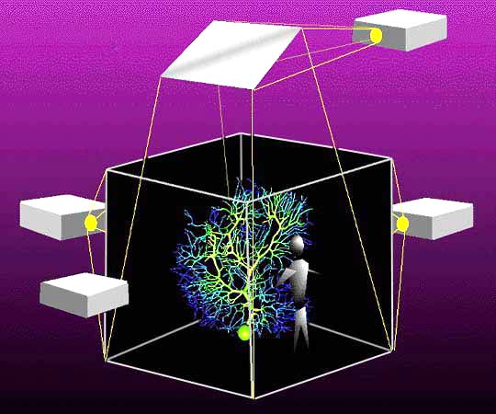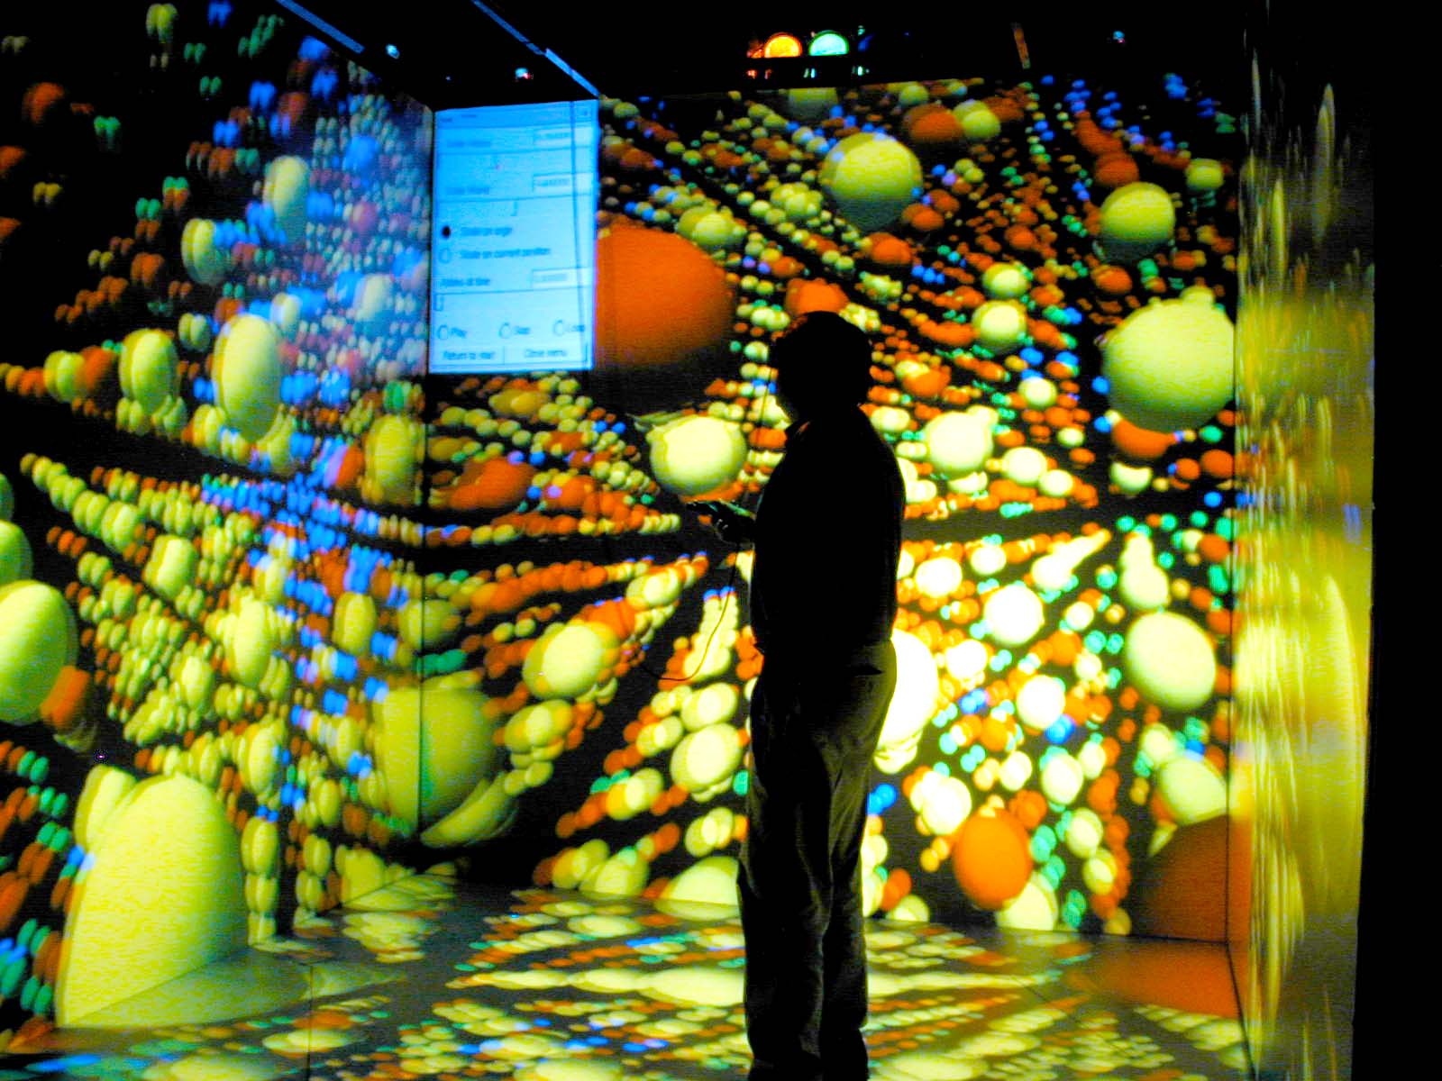
Figure 1. Right image: schematic of a CAVE projection-room showing the location of projectors, Left image: actual snapshot of D_Atomview in the CAVE running the same data set shown in Figure 8.
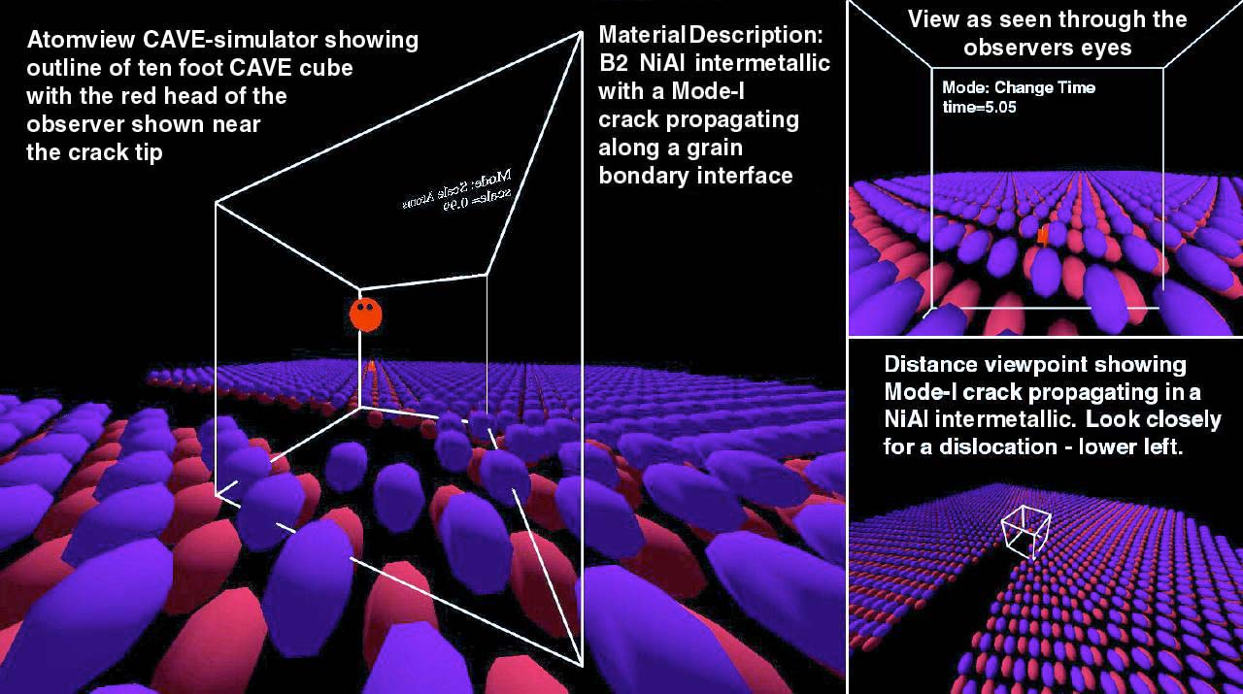
Figure 2. Atomview showing three different views of a B2 NiAL inter-metallic nanostructure as seen by a researcher using a desktop SGI Octane computer viewing HPC results with a CAVE-simulator.

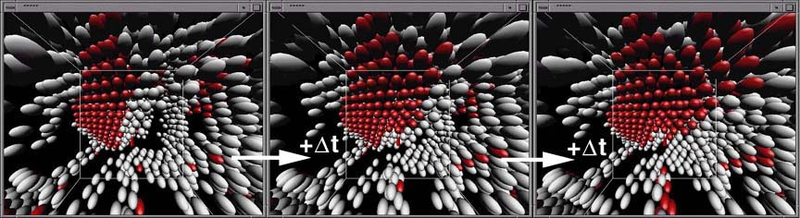
Figure 3. Time animation sequence showing development of stacking faults (red atoms) along Ni grain boundaries
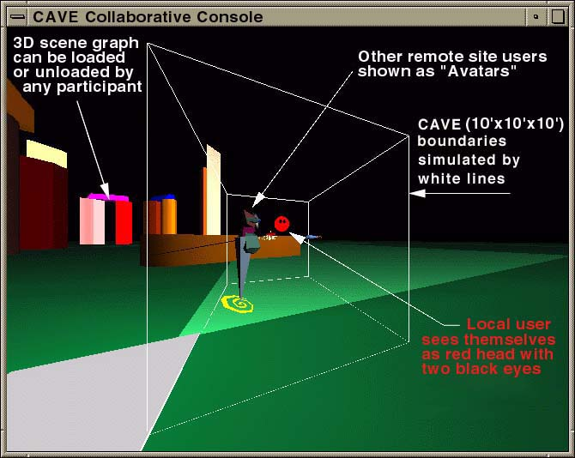
Figure 4. Schematic showing major components of the CAVE Collaborative Console
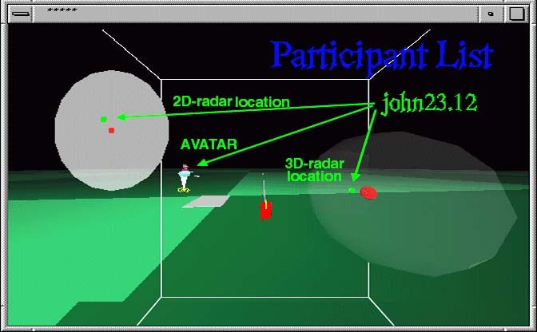
Figure 5. CCC Awareness Tools: Participant List and 2D / 3D participant’s avatar location

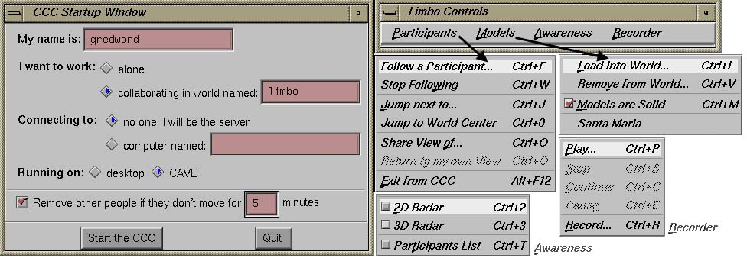
Figure 6. CCC Startup menu: Participants, Models, Awareness, and Recorder
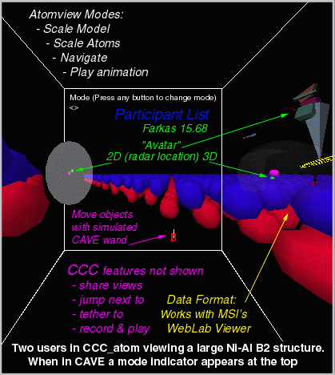
Figure 7. CCC_atom as seen the desktop VE-simulator
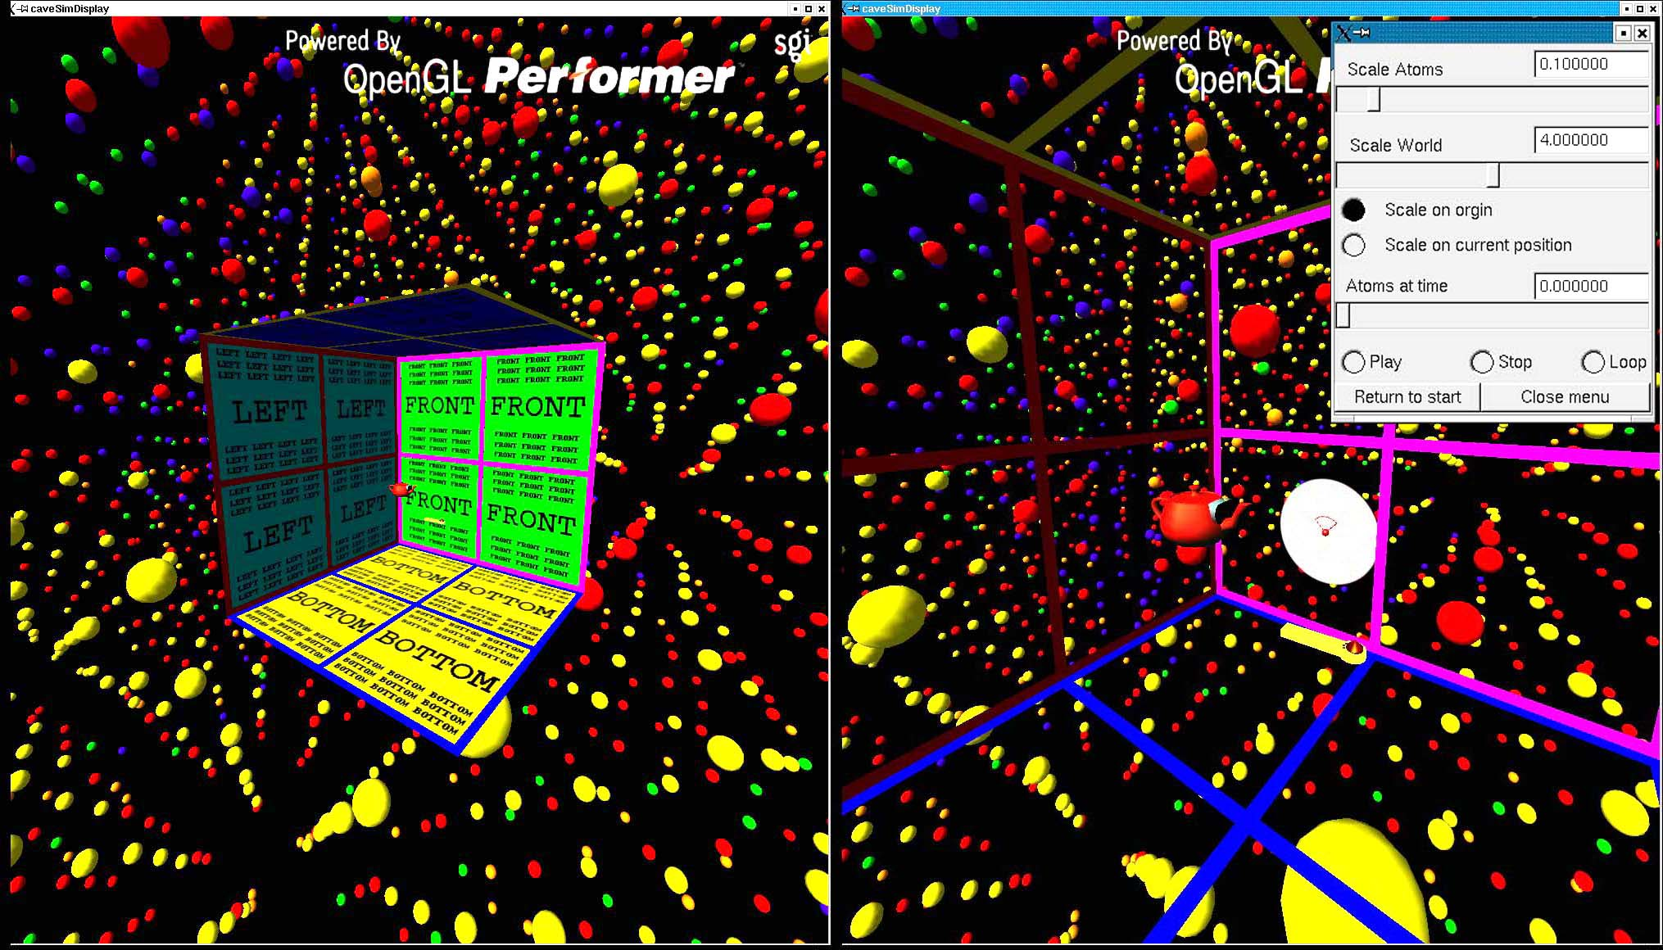
Figure 8. D_Atomview: Left image shows a CAVE-simulator embedded in a Ni nanostructure and the right image shows a closer view inside the VE-simulated CAVE showing 2D radar, user’s head (teapot), and yellow wand.
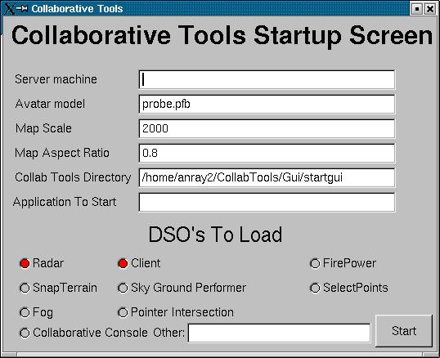
Figure 9. D_Collab_Tool startup screen can be used for any DIVERSE application
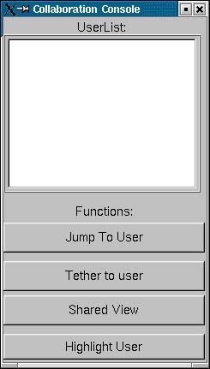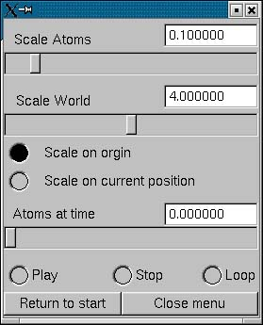
Figure 10. Participant collaborative console shown on right and D_XWand common VE interface shown on the left

™ CAVE is a trademarked name of the University of Illinois, † High Performance Computing: Grand Challenges in Computer Simulations 2003, The Society for Modeling and Simulation International (SCS), San Diego, California, pp. 127-135 (2003).

