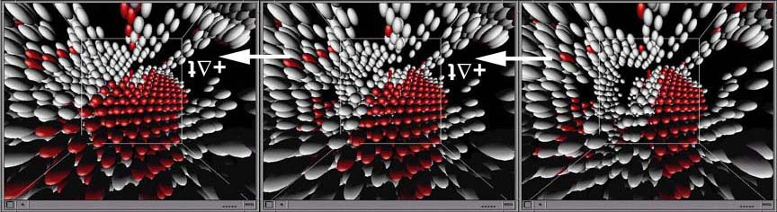

Figure 3 shows the formation of stacking faults along a Ni (FCC-structure) grain boundary. This time-sequence figure shows the emission of a partial dislocation from a Ni grain boundary where only atoms at the grain boundary are shown (gray). The Ni atoms associated with lower energy levels in the interior of the grain have been removed. This allows the researcher an unobstructed view of the atoms that exist at a higher energy state, which is where the formation of stacking faults occurs. The movement of partial dislocation inside the grain creates a stacking fault, which is seen as an increase in the number of red atoms. Although this property can be shown on a desktop VE, this particular animated example is better observed in an immersive Virtual Environment such as a CAVE.

Figure 3 shows the formation of stacking faults along a Ni (FCC-structure) grain boundary. This time-sequence figure shows the emission of a partial dislocation from a Ni grain boundary where only atoms at the grain boundary are shown (gray). The Ni atoms associated with lower energy levels in the interior of the grain have been removed. This allows the researcher an unobstructed view of the atoms that exist at a higher energy state, which is where the formation of stacking faults occurs. The movement of partial dislocation inside the grain creates a stacking fault, which is seen as an increase in the number of red atoms. Although this property can be shown on a desktop VE, this particular animated example is better observed in an immersive Virtual Environment such as a CAVE.

