The NVIDIA Quadro® FX3000 graphics card from PNY Technologies, makes CAVE™ technology more affordable.


“We envision many more universities using the NVIDIA Quadro® FX3000G graphics cards to build affordable visualization systems.“ Ron Kriz, Associate Professor, Department of Engineering Science and Mechanics, and Director of University Visualization and Animation Group (UVAG), and system architects: Andrew Ray and Pat Shinpaugh, UVAG, Virginia Tech, Blacksburg, Virginia

The CAVE™ (CAVE Automated Virtual Environment) system is the most advanced and powerful projection Virtual Reality system on the market. It is configured as a room-sized, cube-shaped facility with stereoscopic graphics projected onto every surface so the images completely surround the users. Normally a CAVE system costs in excess of $1million, but Virginia Tech has designed a system using the NVIDIA Quadro® FX3000G from PNY Technologies that will cost significantly less.

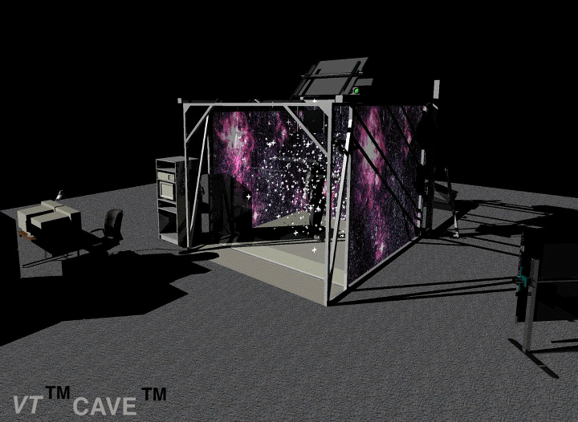
According to Ron Kriz, UVAG Director, “Come this June we will no longer support our old SGI Onyx computer with three IR-graphics pipes and will be totally dependent on the NVIDIA Quadro FX3000G graphics cards to drive our CAVE system.” UVAG has developed a Linux CAVE system that uses four Dell computers with the NVIDIA Quadro FX3000G, quad buffered, genlock graphics cards to drive the four CAVE wall projectors. The CAVE is primarily a graphical system and thus has extremely demanding requirements for its graphics hardware. The NVIDIA Quadro FX3000G card was selected by UVAG because it provides good graphics performance and has built in framelock and genlock that allows UVAG to power the CAVE in full stereo.

“We looked at Wildcat® cards and the ATI FireGL™ cards. One problem with both of these cards is driver support in Linux. Due to the fact that we operate in a pure UNIX® environment these cards are not desirable due to past experience with driver support,” states Kriz.

”With our working DIVERSE Adaptable Display Systems (DADS) published as part of our opensource (http://diverse.sourceforge.net/) philosophy, We envision many more universities using the NVIDIA Quadro® FX3000G graphics cards to build affordable visualization systems. Using DSOs (dynamic shared objects or plugins) and daemons (background processes) in conjunction with the NVIDIA Quadro FX3000G graphics hardware, which is capable of framelock and swap sync, we were able to implement a highly efficient and low cost system to drive the CAVE walls with full synchronization,” Kriz continued.

The CAVE system offers researchers the advantage of immediate, first-hand experience of real-time visual simulation. The CAVE system enables groups involved in manufacturing, telecommunications, engineering, sciences, entertainment and education to perceive spatial and visual data in an immersive environment. These systems create highly realistic and sophisticated interactive simulation environments, ideal for understanding spatial dynamics and interrelationships among objects, people and places. For more information about VT-CAVE™ systems: www.cave.vt.edu

For more information: www.pny.com/quadro

CAVE™ is a trademark of the University of Illinois.
Images courtesy of UVAG

