Date: Thu, 31 Aug 2006 11:58:24 -0400
From: Ron Kriz <rkriz@vt.edu>
Subject: Re: details of my problem
X-Sender: rkriz@pop.vt.edu
To: Jianhua Xing <xing3@llnl.gov>
Cc: rkriz@vt.edu

Jianhua: This is a very interesting problem that can exploit the use of
immersion in the CAVE to analyze and interpret gradients in stress
tensor fields associated with you massive protein structures. With the
data files you provided this is a problem we can visualize in the CAVE.
I will start working on this problem as time allows and keep you updated
as I make progress and/or have questions. I will start by generating
stress tensor glyphs of your data four at a time.

It appears that all of your stress tensors are symmetric. Is that correct?

R.D. Kriz

Date: Wed, 02 Aug 2006 15:31:38 -0700
From: Jianhua Xing <xing3@llnl.gov>
Subject: details of my problem
To: Ron Kriz <rkriz@vt.edu>

Hi Ron,

My problem is like this. For a given protein under stress, I want to visualize the stress distribution. In the enclosed file,
3KTQ_all.bmp shows the structure of an example protein,
3KTQ_alpha shows only the C_alpha atoms (where the stress tensors are defined in the other data file), 3KTQ_b.xyz is the coordinate file (the first column gives the residue index, and the following three gives x, y, and z coordinates)
3KTQ_Stress.dat gives the stress tensors at each C_alpha position (the nine columns in the order xx, yx,zx,xy,yy,zy,xz,yz,zz)
I also enclosed a paper I found from the web, which you may have seen before.

So, what will be your suggestion? What software is available and easy to use? If you are interested, we should work together.

Best,
Jianhua

Contact Information at LLNL:
http://www-cmls.llnl.gov/?url=jobs_and_education-glenn_t_seaborg_institute-previous_fellows

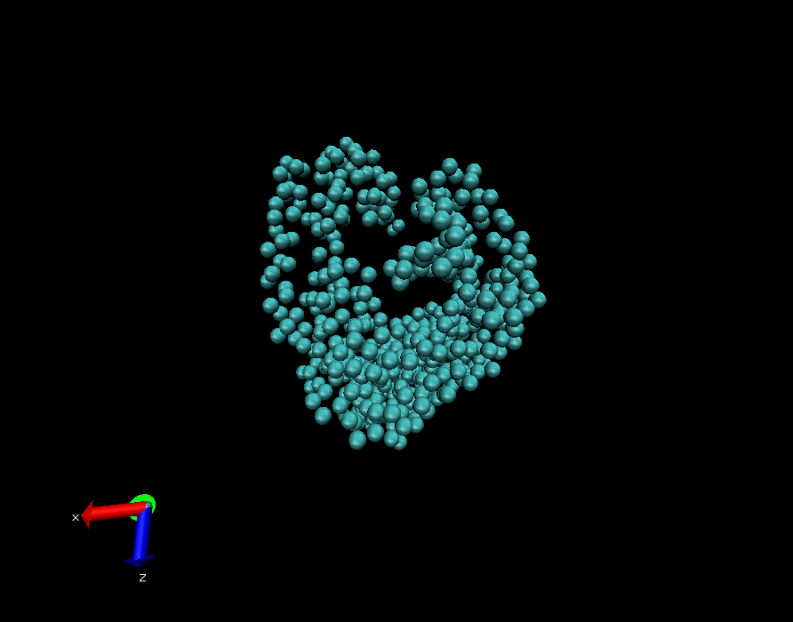

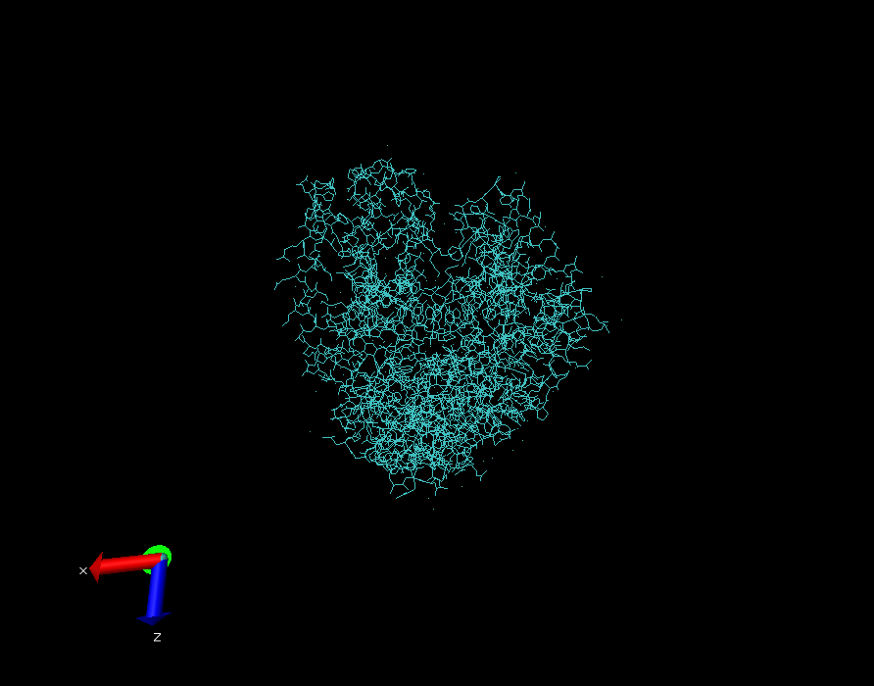

Two attached data files:

- 3KTQ_b.xyz
- 3KTQ_Stress.dat

Both of these files are text files.

