Mosquito B

08-08-05

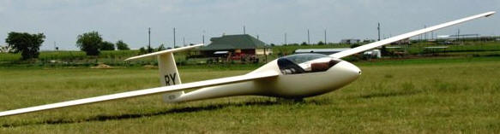

15 Meter with flaps and trailing edge spoilers/dive brakes, Parallelogram stick, Heel brakes, Integrated ballast tanks (115 liters) Competition sealed, Tost CG and nose releases, In-flight adjustable rudders and seat back, Press-to-set trim. Panel: ASI, Compensated 1.2 sec Variometer with audio, Compensated 1.7 sec Variometer with 9v backup power source, Altimeter, Averager, Speed-to-fly calculator, Compass, Oxygen regulator, Voltmeter, 720 Channel transceiver w/Boom mike

36 Cu. Ft. Oxygen Bottle with regulator, flow meter, mask and cannula,,Will Schuemann compensator. Pfeiffer trailer with brakes, Security 150 parachute, New spare gear doors, Battery with charger, Single owner, never pranged, wrecked, dinged or boinked.

$25,000

Contact: Brian Beals at bbeals@attglobal.net

