Note: The gray shaded paragraphs are meant to be sections that are separate from the rest of the paper in separately boxed sections.

An Immersive, Interactive Scientific Visualization Environment for the Analysis of Complex Flows

Abstract:
This project offers a multidisciplinary approach towards the acquisition, analysis and visualization of experimental data that pertain to cardiovascular applications. An immersive, virtual environment (VE) was developed for the investigation and analysis of vortical, spatio-temporally developing flows with complex fluid-structure interactions. This VE was used to study flows in the cardiovascular system, particularly for flow through mechanical heart valves and inside the heart left ventricle (LV). The simulation provides three-dimensional (3-D) visualization of in-vitro heart flow mechanics, allowing global, volumetric flow analysis, and a useful environment for comparison with in-vivo MRI velocimetry data. 3-D glyphs (symbols representing informational parameters) are used to visually represent the flow parameters in the form of an ellipse attached to a cone, where the ellipse represents a second-order Reynolds stress tensor, and the cone represents the velocity magnitude and direction at a particular point in space, and the color corresponds to an out-of-plane vorticity. This new system has a major advantage over conventional 2-D systems in that it successfully doubles the number of visualized parameters, and allows for visualization of a time-dependent series of flow data in the Virginia Tech CAVETM immersive VE. The user controls his/her viewpoint, and can thus navigate through the simulation and view the flow field from any perspective in the immersive VE.

Motivation:
The experimental investigation and analysis of complex vortical flows has always been a very tedious task. The level of complexity increases significantly in the case of spatio-temporally developing flows that involve the interaction of vortices with deformable walls and structures. These types of flows exist in the cardiovascular system, especially in the case of the flow through mechanical heart valves and inside the heart left ventricle (LV). The analysis of such complex systems requires a powerful and adaptive scientific visualization environment.
Tools for visualizing velocities, flow field properties such as vorticity and helicity, instantaneous streamlines, unsteady streaklines, iso-surfaces, and volume slices, have been widely used in the past. Quantitative flow visualization of the heart for evaluation of long-term performance of artificial heart valves is an important topic in blood flow engineering and heart biomechanics. By combining the two systems, one can accurately determine the hemodynamic behavior of these valves, and improved designs can be developed.
The purpose of this project is to integrate these tools with virtual reality (VR) and create an interface between experimental data from TRDPIV and 3-D virtual reality systems. VR is proving to be an increasingly useful visualization tool in biomedical engineering as non-invasive measurement systems expand their capabilities. For example, MRI scans can be turned into immersive 3-D representations that can give clinicians a major advantage over other methods of visualization. By linking this technology with existing TRDPIV data, one creates an accurate representation of the flow under investigation for heart valve performance evaluation and analysis. Advanced 3-D visualization of heart flow mechanics will give increasingly valuable insight into the fluid mechanics of mechanical heart valves, as well as possible modes of improvement. Thus, it is the goal of this study to increase our capability of analyzing and interpreting complex three-dimensional flow fields by taking advantage of the potential of VR environments.

Background and Significance:
Scientific Visualization
The use of computer-based visualization in the representation of experimental data as well as output from numerical models is integral to our ability to gain insight into and make inferences to the physiological function of biomechanical systems. Scientific visualization technologies are necessary when attempting to enhance the brain’s ability to recognize patterns and draw such inferences, as they capitalize upon the high-bandwidth channel of the human visual system. The purpose of scientific visualization is to physically represent a data set using visual tools, such as scaling quantities according to size, color, or shape, in order that the visual cortex of the user is stimulated and can therefore make a qualitative assessment of the occurrence, which can then be analyzed quantitatively in a particular region of interest. This stimulation, however, is reliant upon the quality of the simulation. The human brain has the ability to recognize intricate patterns embedded within complex data sets, and responds most significantly to changes in visual information (Kosslyn 1993). To accomplish this task, the visualization tool requires adequate rendering capabilities such that real-time, smooth data representation can be achieved. Realistic simulation then allows for maximal user inference, based upon the natural ability of the brain to recognize patterns, as well as disturbances in patterns.
Modern visualization technologies are adequate for most commonplace applications, as they are capable of clearly and realistically representing two or three parameters of a data set at one time, and scaling them according to their respective magnitudes. For example, many widely used flow visualization software packages represent a particular flow according to the local velocity at each point within a plane of interrogation, with overlaid vorticity colors, which is adequate when analysis need not include further parameters. However, when it becomes necessary to include additional parameters, the obvious trade-off is the addition of relevant information versus the effectiveness of the simulation. Accordingly, there is a need for newer, more adaptable algorithms and platforms to enhance the effectiveness of flow visualization software for highly complex data sets.
The amount of information represented in a graphical simulation affects two major characteristics of the visualization tool. First, incorporation of an entire data set requires computing technologies not readily available. Second, the human visual system is only capable of comprehending a limited number of visual stimuli at once. Advancements in scientific visualization systems, processes, and technologies have been referred to as a solution to reducing the ever-growing gap between the number gathering/crunching capabilities of data acquisition systems and numerical simulations over the inability of the human physiology to evolve to accommodate the amount of represented parameters or results (Ellson, 1998).
A common solution to the task of visualizing multiple elements of a data set such that highly correlated information can be conveyed appropriately is the use of symbols. An object can convey important information without the need for words or numbers, and the facets that are emphasized or stand out in a picture give an idea of what information is more important than others. The saying, “A picture is worth a thousand words” is true to the very essence of visual communication, as one can depict a single element of a data set, or several entities. Symbols have been used for years to communicate information, dating back to early times in the form of Egyptian hieroglyphics. Modern forms of hieroglyphics accomplish the same effect, and are known as “glyphs.” For example, the weather glyph uses a simple diagram in the form of an arrow with a circle tip to represent wind speed magnitude and direction at a particular location, as well as the sky cloud cover (Ellson, 1998). The glyph maximizes the amount of information that can be represented graphically within a limited amount of space.

Current Virtual Environment Developments:
The use of virtual environments in scientific visualization has been identified as advantageous in solving engineering and science problems. In recent years, increasing efforts have been directed toward the visualization of data in virtual environments (VE), which is also referred to as virtual reality (VR). Here VR and VE are used interchangeably. In particular, VR has been utilized for the display and manipulation of scientific data from natural phenomena, including weather, fluid and particle dynamics, and other information that is highly dependent upon spatial coordinate data. These environments have been successful in representing experimental data, obtained through data acquisition and numerical simulation of natural phenomena. The usefulness of these systems is attributed to the value of their enhanced human-computer interface that allows easy manipulation of data to maximize the use of the senses (van Teylingen, 1997). Coupled with the ability to interact and immerse oneself within the simulation, this facet allows a problem to be approached with a user-controlled, systematic engineering analysis approach.
Virtual Reality (VR) has emerged as an ideal platform for scientific visualization due to its ability to convince the senses, which provides a solution to several problems that limit the functionality of current modes of scientific visualization. The potential for VR applications is regarded to be especially high in the area of data visualization and analysis, particularly in the visualization of highly complicated, interdependent multivariate data that can be updated which each frame for real-time simulation. Most VR environments are currently in their infant stages, however, and serve more of an artistic/gaming purpose than the scientific analysis tool of which they are capable. One VR-based data visualization project that aims to improve the usability of virtual environments is the ‘Virtual Data Visualizer’ (van Teylingen, 1997) a system that acts as the basis for a toolkit for the visual analysis of complicated data sets, while giving the ability to focus the application to address specific needs.

Virginia Tech CAVETM:
The Virginia Tech CAVETM (Cave Automated Virtual Environment) is currently being used to develop the scientific visualization system. The CAVETM is a 10’ x 10’ x 9’ theater, consisting of projection screens on the front and side walls. Stereo goggles bring two slightly offset images into focus in front of the walls, giving the user the illusion of immersion within the simulation. The viewpoint of the user is controlled by a six-degree-of-freedom electromagnetic sensor in the goggles, and manually using a similar sensor in a joystick controlled by the user. The major advantage of the CAVETM system is that it is a fully networkable collaborative environment, and is now cross platformed for use on any computer system through a program called DIVERSE [www.diverse.vt.edu]. Thus, a scientist running the simulation in the Virginia Tech CAVETM could communicate with a cardiologist halfway across the world viewing the same simulation on a desktop PC. Avatars, which are essentially simple human models, virtually represent the users with in the simulation, and headsets are used for verbal communication between the users [Collaborative Tools: www.sv.vt.edu/future/cave/software/D_collabtools/D_collabtools.html].

Application to Cardiovascular Flow:
Time-Resolved Digital Particle Image Velocimetry (TRDPIV) is a non-intrusive state of the art global flow measurement technique that has been developed over the past ten years. A major advantage of TRDPIV over preexisting methods is the ability to provide global spatio-temporal description of three-dimensional (3-D) flow patterns with high spatial and frequency resolution, such that the turbulent characteristics of the flow are measurable. However, the data analysis process is limited by current visualization methods that are generally capable of only 2-D representations.
The ESM Fluids Laboratory cardiovascular hemodynamics group has acquired extensive TRDPIV data from in-vitro experiments in various fields, including flow over bluff bodies, two-phase flows, and cardiovascular flows. Of particular interest is the behavior of fluid flow through the left ventricle. A heart machine was developed for the testing of mechanical and biological heart valves. The heart machine (Figure 2) uses a piston-driven chamber to generate physiological contractions of a synthetic ventricle.

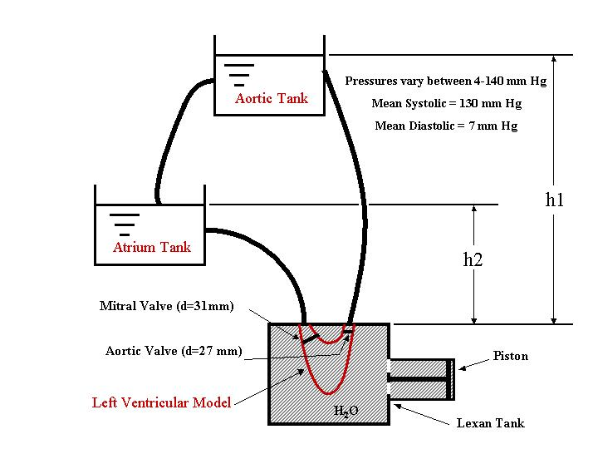
Figure 2: Heart Simulator Setup (Pierrakos, 2002)

Data Acquisition System:
TRDPIV provides instantaneous plane velocity measurements of the flow field. Detailed description of the principles of the method can be found in Willert and Gharib (1991), Westerweel (1993). The system used is based on a 55-Watt pulsing laser that illuminates the area of interest. The flow is seeded with neutrally buoyant fluorescent particles, which serve as flow tracers. A very fast CMOS video camera is synchronized with the laser to capture with up to 1000 frames/sec and 512x512 pixel resolution the instantaneous positions of the particles. The task of the velocity evaluation is carried out using conventional cross-correlation between the particle image patterns of two consecutive frames. A detailed description of the system is found in Vlachos (2000). For the present work data are acquired along a sequence of parallel planes to allow the reconstruction a volume of the flow field. A schematic of our setup is shown in Figure 1.
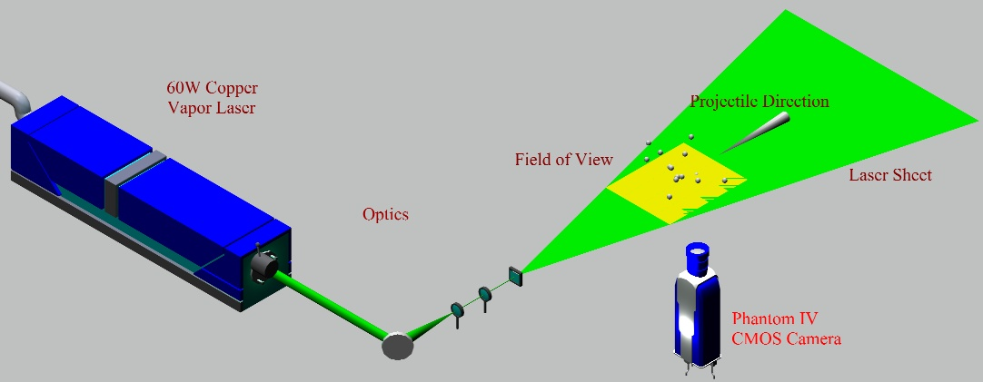
Figure 1: DPIV Setup (Pierrakos, 2002)

Approach for developing an optimal visualization tool:

Previous Work
Figure 9 shows a conventional representation of the instantaneous flow field, using a conventional scientific visualization software package, for a single plane downstream the mitral valve, inside the left ventricle. The vectors correspond to velocity distribution, while the color mapping represents vorticity values. It is clear that reconstruction of a volume of data of such a complex three-dimensional flow field would significantly compromise our ability to extract flow features. The use of a virtual environment can provide significant advantages, as it allows the investigator to be “immersed in the flow”, such that one can move close to small-scale structures in order to focus on the detail or distant oneself and observe the global flow characteristics.

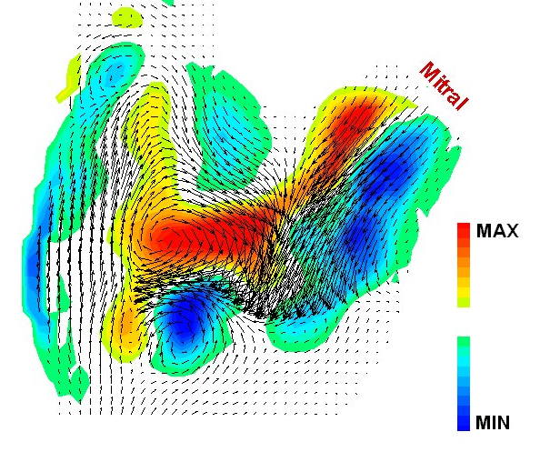
Figure 9: A two-dimensional representation of the velocity and vorticity distribution in the flow field downstream the mitral valve

There are several flow properties other than velocity and vorticity that are of particular interest in cardiovascular flow, including Reynolds stresses and wall shear stresses. This information can double, or even triple, the quantity of data that can be visualized. Each plane of data can be resolved into instantaneous flow information composed of tens or hundreds of thousands of points within each plane, for several planes within a flow. As a result, the amount of data obtained from these experiments to describe only one or two seconds at a sampling rate of 1,000 Hz is on the order of hundreds of megabytes, and the memory required to visualize these parameters is on the order of ten to twenty gigabytes. Therefore, there is a need for a method for visualizing complex data sets while maintaining computational efficiency and without confusing the user.

Methodology for improved flow visualization
The first step in the process of developing an effective visualization tool is to determine the important parameters to be represented in the simulation. Beyond spatial parameters, only the most important information should be displayed, as the simulation is limited by the technological capabilities of the visualization system and the processing limitations of the user on the amount visual stimuli (Ellson, 1998). Incorporating too much information can drastically reduce the frame rate of the system, causing interruptions in playback and an overload of visual stimuli to the visual cortex, reducing the effectiveness of the simulation. In addition, an excess of visual stimuli can overload the visual cortex.
Next, a graphical method of visualization can be chosen. Ellson (1998) suggests that the dimensions and form of the glyph in the simulation should be used to represent vector terms, with the magnitude of the vector determining the dimensional length of the glyph. The time-dependency of the vector quantity can then be recognized as the change of the shape of the glyph as the simulation progresses. Scalar values are generally best represented by the color of the glyph. The success of the color map is determinant upon the range of colors chosen for the display. Many simulations have used the colors of the visible spectrum to represent the scalar quantity. The spectral colors do not convey the information of the values accurately, though, as they range from blue to red, with yellow in the middle. The failure of such a color scheme lies in the fact that a ‘hot’ color, or one to which the eye is particularly attracted, i.e. yellow, should represent an extreme value, not a middle value. In most scientific applications, we are most often concerned only with how a parameter deviates from its average value to extreme values. For example, for fluid flow through a particular space, areas of low vorticity are usually associated with a locally steady flow. Areas of high vorticity, on the other hand, are usually characterized by circular, turbulent flow patterns. These turbulent parts of the flow are important in analyzing boundary layer phenomena, as well as in wave and wake propagation. Accordingly, the extreme values of a scalar parameter should be mapped to these so-called ‘hot’ colors.
For the visualization of flow data within the left ventricle, the most important parameters include the spatial (x-, y-, and z-dimension) coordinates, the velocity components (u, v, and w corresponding to the x-, y-, and z-dimensions), and vorticity perpendicular to the plane of interrogation. In addition to these parameters, we would like to be able to visualize the calculated Reynolds stress, a second-order tensor important in identifying regions of high-level stresses on blood particulates. In order to represent the parameters in a compact yet comprehendible manner, our system utilizes glyphs to represent the data. The glyph designed for the heart flow simulation consists of a cone attached to an ellipse, as shown in Figure 12. The cone represents the magnitude of the velocity at a single point, and its orientation the direction. The ellipse is scaled to the values of the symmetric Reynolds stress tensor at that point, with the lengths along the axes perpendicular to the axis of the cone representing the two in-plane Reynolds stresses, and the axial length corresponding to the cross-correlation term between the two. The color of the glyph represents the magnitude of the vorticity, with brighter colors indicating severe or extreme values. Thus, one single glyph concisely represents nine flow parameters for a single point within the flow.
For the present time, and for the purposes of the following examples, the 3-D glyphs are confined to a 2-D plane because the acquired experimental TRDPIV data were limited to measurements within that plane at that time. The visualization system is however capable of representing 3-D data, such that when actual volumetric data is acquired the VE is designed to accommodate the data. Our system is currently capable of these measurements.
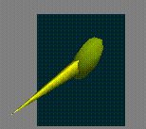
Figure 12: Flow vector glyph

Reynolds Stress Tensor
The Reynolds stress tensor mentioned above gives valuable insight into the nature of the flow, particularly pertaining to the stress due to turbulent structures. We first define the velocity as the sum of the time-varying mean flow plus a term representing the variation from this mean:
u(t) = u(t) +u’(t)
This relation describes an easily recognizable mean flow with high-pressure fluctuations of a much smaller magnitude. An oscillatory flow is shown below in Figure 13, first the mean flow (a), then the fluctuations (b), and finally the sum of the two flows (c).

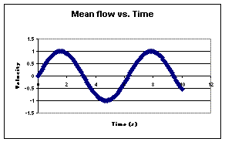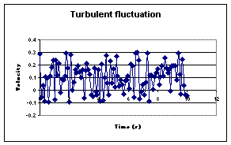
(a) (b)
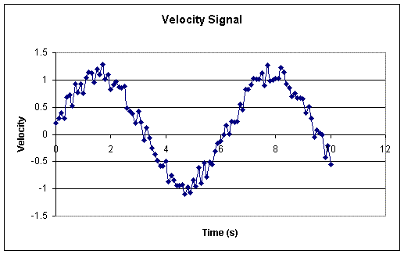
(c)
Figure 13: Sample mean sinusoidal velocity signal (a); turbulent fluctuations (b); and combined signal

Next, we define the Reynolds stress tensor as the outer product of the turbulent velocity terms:
Rij = [u’_{i}² u’_{i}u’_{j} u’_{i}u’_{w}
u’_{i}u’_{j} u’_{j}² u’_{j}u’_{w}
u’_{i}u’_{w} u’_{j}u’_{w} u’_{w}²]
The significance of the Reynolds stress tensor can be viewed from a classical turbulence standpoint, where the correlation between u1 and u2 can be used to describe turbulent transport in the form of an energy cascade. The energy cascade explains the phenomenon by which, in a fully developed turbulent flow, energy is transferred from the low-frequency scale to subsequently higher-frequency scales, until the energy from the flow is dissipated in the form of heat. A classical example of this phenomenon is the concept of vortex tube stretching. To illustrate this phenomenon, take for example a shear flow in Figure 14(a). Instantaneous streamlines are shown within the flow, showing the existence of organized vortical flow structures, which are maintained by entraining energy from the flow. The turbulent energy transport of these eddies involves their three-dimensional interaction with the mean flow, where the eddies that are able to absorb energy from the flow most efficiently are those that are aligned axially with the direction of mean strain rate. The result of this interaction is known as vortex stretching, whereby the vortex is elongated, shown in Figure 14(b). At the same time, however, the stretching causes a contraction of the radial dimension of the vortex. Thus, although most of the energy has been maintained, the scale of the flow has changed. From a frequency scale standpoint, a free stream represents the lowest possible frequency (f = 0) and the energy decreases with the radial dimensions of the eddy. In this manner, as vortex stretching occurs and the radial dimensions of the eddy decrease, the energy that was once contained in a low frequency is transferred to a higher frequency. This process continues until the energy is finally dissipated as heat (Tennekes, 1994).
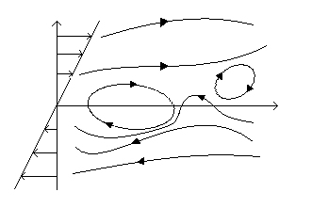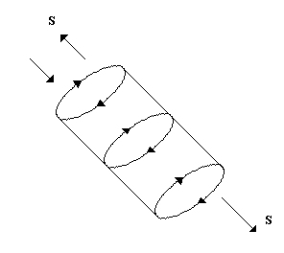
Figure 14: (a) Shear flow with streamlines (left); (b) Vortex stretching process (right)

Thus, the Reynolds stress tensor is integral to our understanding of vortex generation and breakdown, and how these phenomena cause regions of low and/or rapidly fluctuating pressure, eventually leading to damage to blood constituents and endothelial cells. As such, it is necessary to visualize this stress tensor for the current application.

Results:
Visualization of In-Vitro Left Ventricular Flow Data

The scientific visualization software is designed as a tool for interactive simulation and analysis. As such, the single most important aspect of the software is its user-controlled design. The scientist can move through the tens of thousands of data points, and probe or isolate points/areas of particular interest or concern using the red, cone-shaped probe wand. Once a point is highlighted, it is enlarged such that it stands out from the rest of the points, and is shown above on a pop-up display. These features are shown in Figure 15, which displays a single two-dimensional plane of 61 x 61 data points. Once the user has selected a point in the data set, there are various options for controlling the simulation. For example, with the push of a button the simulation can be altered such that a new set of glyphs are used to isolate only selected parameters. Figure 16(a) shows a contour surface representing only the spatial distribution of the Reynolds stress tensor over the plane. The contour is made up of cylinders of equal height, with the two horizontal axes scaled to the in-plane values of the tensor, and the color according to a cross-correlation term. Normally all three dimensions would be scaled to the three eigenvalues of the tensor, but due to limitations in the data acquisition system that allow only in-plane measurements, the known values are used for the purpose of illustrating the tool. By clicking a second button, a set of iso-points is created as represented by the overlying colored spheres, showing the set of points that have a vorticity level close to the value of the selected point (Figure 16(a)). This tool allows the user to compare contours of a single or few parameters to recognize correlations in the data set from a global viewpoint.

The program displays five separate planes, each composed of a grid of 125 x 125 points, which are displayed as glyphs. The areas that appear to be denser than others, those near the top, are regions of high Reynolds stress. The vorticity is represented by the color of the glyphs, with brighter colors signifying higher values of vorticity. Figure 17 shows a pair of images displaying the full time-averaged flow through the heart, from both the frontal view and an oblique view. The system has the advantage that it almost doubles the number of visualized parameters from six (x, y, x-velocity, y-velocity, time, and vorticity) to eleven (x, y, z, x-velocity, y-velocity, z-velocity, time, vorticity, and three Reynolds stress parameters). In addition, five planes are visualized simultaneously, as opposed to just a single plane of data.

Time resolved three-dimensional velocity, vorticity, and Reynolds stress data are imported into the virtual environment using software that we developed in C++, OpenGLTM and VRML in order to convert the spatial coordinate and 3-D velocity data from the PIV system into a series of glyphs in three-space to represent the flow. Each time step allows for instantaneous changes in the velocity magnitude and direction associated with each coordinate, creating a time-dependent series of frames that depicts the state of the velocity field as it changes in time, or frame-by-frame as controlled by the user in the CAVETM environment. The user can then move through the flow and view the flow field from the perspective of a particle in the field. It is important to note, however, that our system is currently limited to interrogating only individual planes of data that are stacked to form a volumetric data set. Although the planes of data are not acquired simultaneously, they are triggered at the same point in the heart cycle, and the experiments have been repeatable. Presently data is confined to the plane. There are no out-of-plane velocity or Reynolds stress components; hence glyphs shown in Figures 15-19 have no out-of-plane components. At the same time, our visualization system is designed such that it is capable of displaying true three-dimensional volumetric data for such a time as is allowed by our data acquisition system.

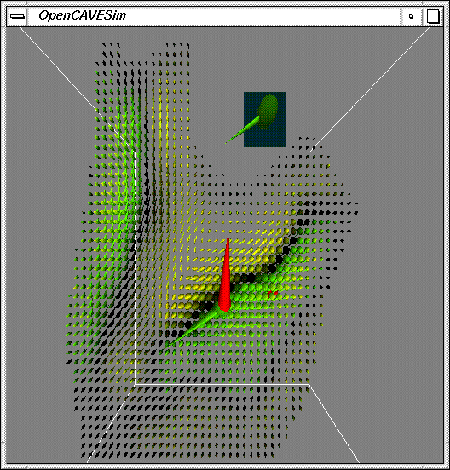
Figure 15: Planar flow glyphs
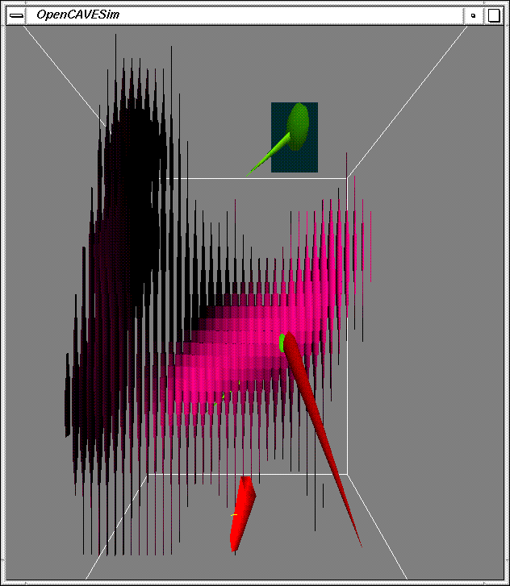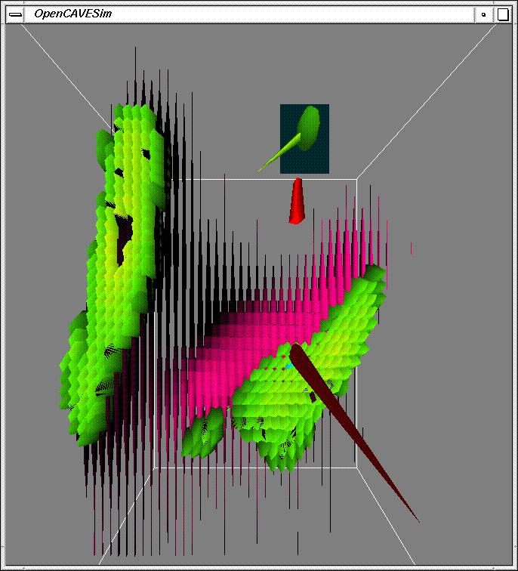
Figure 16: (a) Planar Reynolds stress contours (top), (b) Stress contours (bottom)
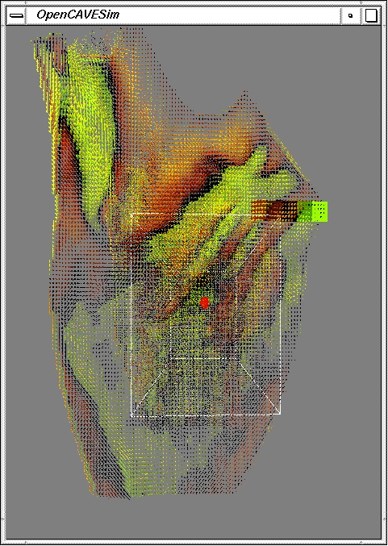
(a)

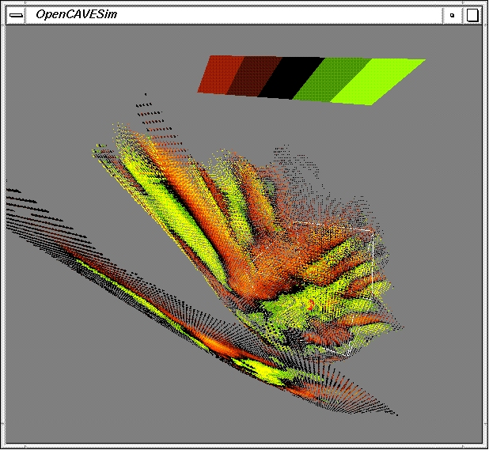
(b)
Figure 17: 3-D time-averaged flow through left ventricle (5 planes); (a) front view (b) oblique view

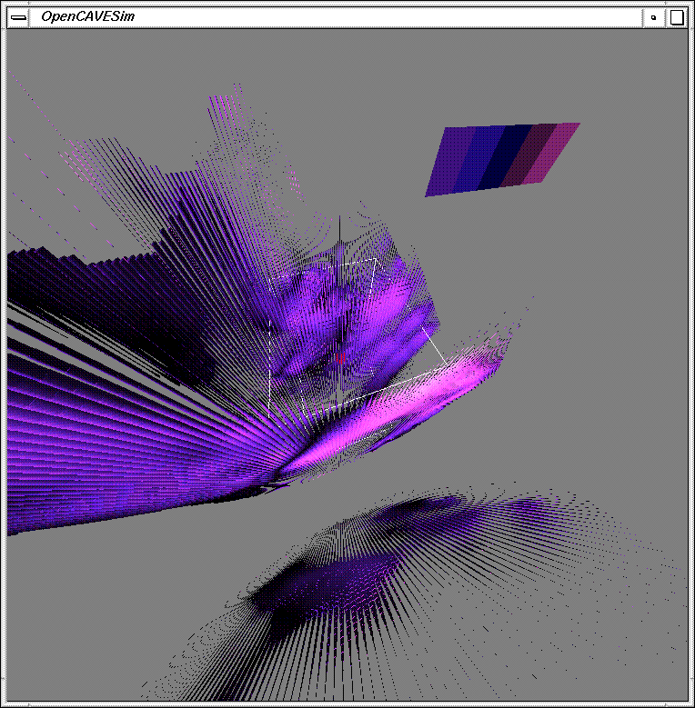
Figure 18: Full 3-D Reynolds stress glyphs

The series of pictures shown below in Figure 9 represent six time-steps of an unsteady heart flow data set. The user is viewing the simulation from the top of the heart on the aortic side. The arrows point up and out of the picture at the top left represent the outflow of blood through the aorta. The arrows point in the direction of the flow at each point in space and time, and the color is scaled to the value of the vorticity, according to the legend shown in the upper right-hand corner. The vortices can be easily followed as they move through the heart for multiple layers of data. The scientific visualization system is an excellent tool for monitoring such parameters at particular points in space or in the volume as a whole.

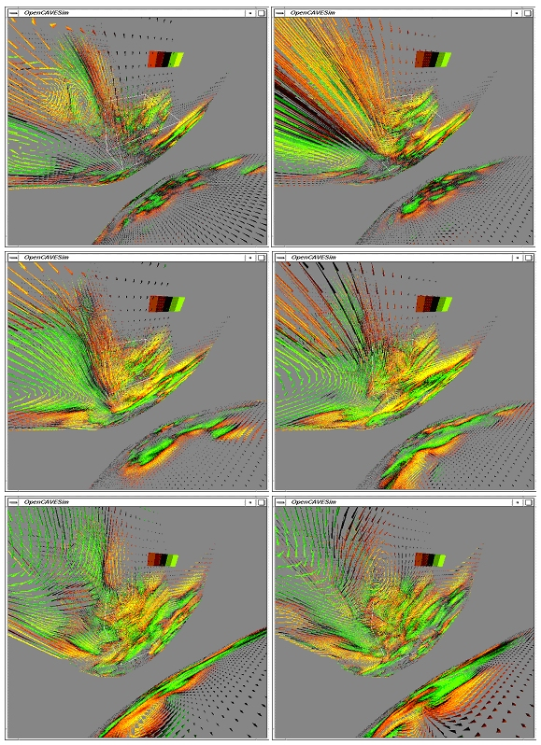Figure 19: Unsteady time-series of 3-D flow glyphs in the left ventricle (left-to-right then down)
Visualization of MRI Velocimetry Flow Data

A major goal of this project was to compare the in-vitro left-ventricular flow data obtained in our laboratory with MRI velocimetry flow data obtained by clinicians at Wake Forest University. MRI velocimetry is a method by which time-resolved blood flow velocity measurements are calculated from MRI images. The visualization of this information would have been invaluable and integral to the evaluation of our system, methods, and results. However, we were unable to obtain this data unlike we originally anticipated. As a result, the successfulness of the results of this research is significantly compromised. It should be noted, however, that the program is designed such that this data can easily be ported into the visualization environment.

Conclusion:

The purpose of this project was to develop a virtual reality environment for the experimental investigation and analysis of complex vortical flows, with application to cardiovascular hemodynamics. An interface between experimental TRDPIV data obtained in our laboratory using our heart simulator and a state-of-the-art 3-D virtual reality system was created. The software creates an accurate representation of the flow under investigation for heart valve performance evaluation and analysis. The simulations give full 3-D visualization of heart flow mechanics, increasing the ability of the scientist to evaluate the fluid dynamical performance of mechanical heart valves. The result is an increased capability of analyzing and interpreting complex three-dimensional flow fields.

3-D glyphs (symbols representing informational parameters) are used to describe the flow in the virtual environment in a concise and informative manner. The glyphs are shaped in the form of an ellipse attached to a cone, where the ellipse represents the 3-D Reynolds stress tensor, and the cone represents the velocity magnitude and direction at a particular point in space. The glyph is color-coded according to an out-of-plane vorticity. This new system has a major advantage over conventional 2-D systems in that it successfully increasing the number of visualized parameters from six (x, y, x-velocity, y-velocity, time, and vorticity) to eleven (x, y, z, x-velocity, y-velocity, z-velocity, time, vorticity, and three Reynolds stress parameters), and five planes (or more depending upon the available data) are visualized simultaneously, rather than just a single plane of data.

The simulation allows for instantaneous changes in the velocity magnitude and direction associated with each coordinate, creating a time-dependent series of frames that shows the dynamical nature of the flow in the CAVETM environment. The user controls his/her viewpoint, and can thus navigate through the simulation and view the flow field from any perspective in the virtual environment.

T M CAVE is a trademark name of the Universtity of Illinois
T M CAVE is a trademark name of the Universtity of Illinois

