Task 2.1 Command & Control Visualization – Ronald Kriz, Lance Arsenault,
and John Kelso

Summary: The NAVCIITI project under task 2.1 experienced several modifications as our Navy Point of Contact (POC) collaborations and resources evolved and as we learned how to implement and use state-of-the-art Virtual Environment (VE) hardware and software tools to build usable command and control interfaces for naval undersea warfare applications. VE hardware and software is “cutting edge” technology and is constantly evolving. This evolution was also indicative of an active participation between the Virtual Realty Laboratory at the Naval Research Laboratory (NRL-POC: Dr. Larry Rosenblum), the Naval Undersea Warfare Center (NUWC-POC: Mr. Kenneth Lima and Mr. Richard Shell), and the Virginia Tech University Visualization and Animation Group (UVAG-Co-PIs: Dr. Ronald Kriz, Dr. Lance Arsenault, and Mr. John Kelso). This evolution is also reflected in Statements of Work (SOWs) and quarterly reports, which have been posted on the NAVCIITI Task 2.1 Command and Control Web pages: http://www.sv.vt.edu/future/cave/resprj/navciiti/nuwc_task2-1/task2-1.html.

Noteworthy accomplishments for task 2.1 was the development of a new VE Application Programming Interface (API) called DIVERSE (Device Independent Virtual Environment: Scalable, Reconfigurable, and Extensible), http://diverse.sourceforge.net, that created a new architecture for working with Input/Ouput (I/O) devices and Dynamic Shared Objects (DSOs) that facilitated moving executable objects into and out of a simulation based design during execution within a VE. Because this API is device independent it scales so that applications run the same in a CAVE, Immersive Work Bench, Head Mounted Display, or a VE desktop simulator. The new I/O and DSO VE architecture also facilitated the development of networked collaborative VE design environments. This new VE-API not only benefited task 2.1 but other NAVCIITI Tasks that used the motion based platform as an I/O device, which was constructed in the floor of the CAVE at Virginia Tech. This benefit to the Navy continues as the DIVERSE API is now supported as an open-source (“free” – GPL/LGPL license) format on the Sourceforge Web site and maintained by a newly formed company, Opentech Inc., http://www.opentechinc.com, located at the Corporate Research Center at Virginia Tech. The future benefit to the Navy has already been realized where Opentech Inc. has been active in setting up and supporting other Navy projects using DIVERSE as the primary VE software API. At Virginia Tech the UVAG is now supported under the Institute for Critical Technologies in the Applied Sciences (ICTAS), a university initiative that will facilitate future VE research of interest to the Navy.

2.1.1 Review of Task Activities

Tasks were organized and reorganized over the last five years into four chronological segments:

BAA 98-014: First year

- Design requirements established for developing command and control VE hardware and software design environment.

BAA-0007: Years 2-5

- Years 2-3: Collaboration with NRL, NUWC, and UVAG-VT organized as the
NUWC: CONRAY-SubVE, and NRL: DRAGON-IVRS projects.

- Years 3-4: Task 2.1 subdivided into two subtasks:
  - Task 2.1a, NUWC-TALOSS OpenGL project in DIVERSE called DGL.
  - Task 2.1b, Development of DGL in support of TALOSS.

- Final year five: Task 2.1 recombined into one task, developing DGL and TALOSS.

Statements of Work (SOWs) and quarterly reports of accomplishments can be accessed from the NAVCIITI Task 2.1Web site: http://www.sv.vt.edu/future/cave/resprj/navciiti/nuwc_task2-1/task2-1.html. The task chronology listed above is indicative of how the collaboration between the Virtual Reality Laboratory at the Naval Research Lab (NRL), the Naval Undersea Warfare Center (NUWC) at Newport Rhode Island, and the Virginia Tech University Visualization and Animation Group (UVAG) evolved into a working relationship over the last five years.

2.1.1.1 Task summary years one and two
Our task objective was to provide a distributed collaborative network of graphical and device independent tools in a shared virtual environment, which can be used by Command and Control (C&C) personnel to gain a strategic advantage. In year-one we focused on cognitive processes that could be used in tactical decision making processes and the creation of shared collaborative virtual environments such as the CAVE Collaborative Console (CCC). In year-two we focused on the mission critical C&C interpretation of acoustic undersea data from towed arrays for the Naval Undersea Warfare Center (NUWC) using the CONRAY simulation models. These simulation models can be extended to "real-time" data acquisition systems such as ICE. Under the direction of personnel from NUWC and the Naval Research Laboratory (NRL) we have identified a working prototype, "MIX", which we have successfully incorporated into our Device Independent Virtual Environment Reconfigurable-Scalable-Extensible (DIVERSE) tool that works in stereo in the (C)AVE Automated Virtual Environment (CAVE), Immersive Work Bench (IWB), Immersive Desk (I-Desk), desktop workstation simulator, and Head Mounted Display (HMD) systems at the Virginia Tech UVAG, see Figures 2.1.1, 2.1.2, and 2.1.3.

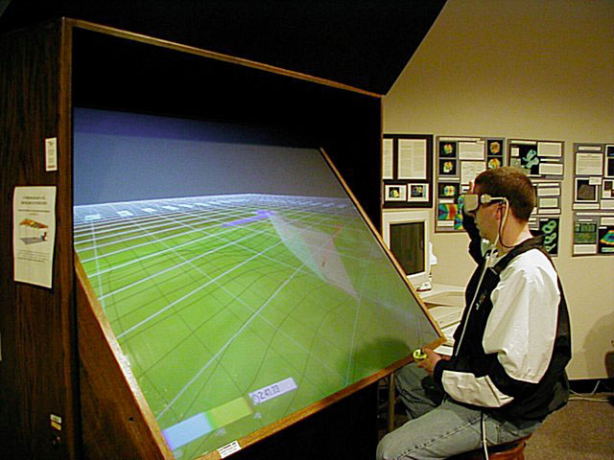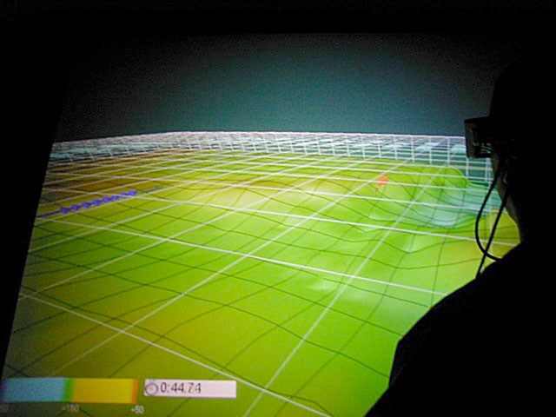
Figure 2.1.1 Performer based TALOSS on the UVAG I-Desk at Virginia Tech

2.1.1.2 Task summary years three, four, and five
In the third year this research has become part of the NUWC-TALOSS (Three-dimensional Advanced Localization-Observation Submarine System) project. The third year also required the sub-division of task 2.1 into two tasks. Task 2.1a continued the development of TALOSS based on the new OpenGL version of DIVERSE called DGL and task 2.1b focused development of DGL used by task 2.1a.

In year three Task 2.1b was directed by a new NAVCIITI CoPI, Dr. Lance Arsenault who was the author of the DTK portion of the DIVERSE API that “glued” various Input/Output (I/O) devices into a network shared memory architecture which was used for simulation based design in support of task 2.1a and other simulation based design NAVCIITI projects such as the Virtual Craneship project. When Dr. Arsenault left Virginia Tech, Mr. John Kelso became the CoPI the fall 2003, and when Mr. Kelso left Virginia Tech in the June 2003, Dr. Kriz became CoPI of both tasks, who recombined both tasks back into one task 2.1 (year five).
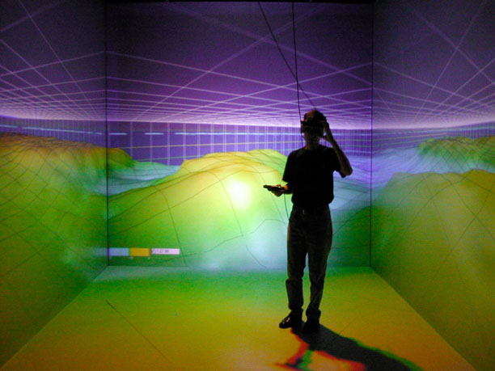
Figure 2.1.2 Performer based TALOSS in the UVAG CAVE at Virginia Tech

In year four a Micorsoft Windows version of DTK was created where DTK and DPF were released as separate DIVERSE 2.3.x modules. The summer of 2004 was the last year and was a critical year for task 2.1b. In the absence of Dr. Arsenault and Mr. Kelso, who were the original DIVERSE API authors, Dr. Kriz hired Mr. Andrew Ray, Mr. Patrick Shinpaugh, and Mr. Daniel Larimer who successfully created a beta release of DGL that is now accessible for the DIVERSE Sourceforge Web site: http://diverse.sourceforge.net. DGL was successfully used to create TALOSS-DGL by Mr. Rich Shell at NUWC and Mr. Fernando das Neves, the NAVCIITI GRA at UVAG, see Figure 2.1.4. Although DGL was successfully used to create TALOSS-DGL, DLG at best was a beta version with minimal documentation. The lastest working copy of TALOSS-DGL can be accessed from the NAVCIITI Task 2.1 Web site. Mr. Andrew Ray became the new NAVCIITI GRA replaced Mr. das Neves, who continued to work with Mr. Patrick Shinpaugh from the summer 2004..

2.1.1.3 DIVERSE Adaptable Display System (DADS) year five.
In year five Mr. Andrew Ray and Mr. Patrick Shinpaugh created a new OpenGL based VE computing system to control the CAVE at Virginia Tech and similar VE systems for the Navy. The development of the OpenGL DIVERSE Adaptable Display Sytem (DADS) was completed and documented on the Sourceforge Web site. A more complete set of DADS documentation is also available from the NAVCIITI Task 2.1 Web site.

The DADS system used PNY Technologies FX3000 quad-buffered/genlock NVIDIA cards, which was acknowledge on PNY’s case study Web site, http://www.pny.com/pressroom/caseStudies/vc.asp, as an affordable alternative to expensive legacy VE computing systems or large expensive Linux cluster systems. Future OpenGL based VE applications are supported on the new DADS systems by the use of the DIVERSE interface to SGI-Performer for OpenGL (DPFGL). The new DPFGL interface is fully documented and can be download from the DIVERSE Sourceforge Web site. This was demonstrated by successfully running OpenGL Visualization ToolKit (VTK) applications on a DADS system controlling the Virginia Tech CAVE projection system.

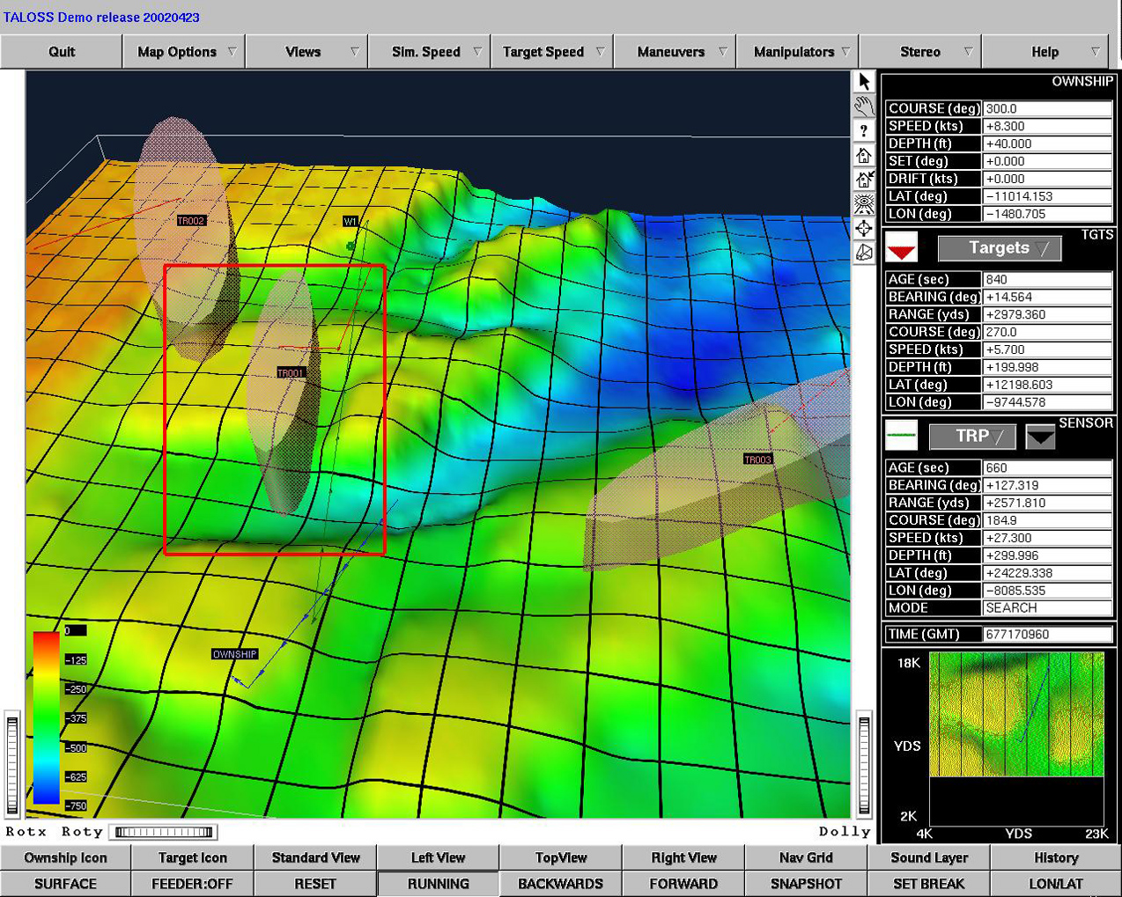
Figure 2.1.3 Inventor based TALOSS on a Linux desktop computer.

2.1.1.4 TALOSS Project Description
A significant issue in today's Navy is the effectiveness with which naval combat systems can be operationally integrated to yield maximal battlespace awareness for the commanders and crews of all vessels involved. A critical requirement is a common operational/tactical picture. Information superiority can be achieved through a better awareness and understanding of the battlespace. Creating a detailed cognitive picture of the undersea battlespace is vital for the success of the undersea warfare mission. The challenge in achieving "speed of command" is in developing an awareness and understanding of the entire battlespace.

Traditionally and currently, decision makers develop a "mental model" of the battlespace by assimilating data from multiple two-dimensional (2D) displays and paper plots. In situations requiring immediate action, the mental processing required to extend 2D representations to a third dimension uses valuable time and energy. A significant issue in this concept pertains to the effectiveness with which naval combat systems can be operationally integrated to yield maximal battlespace awareness for the commanders and crews of all vessels involved.

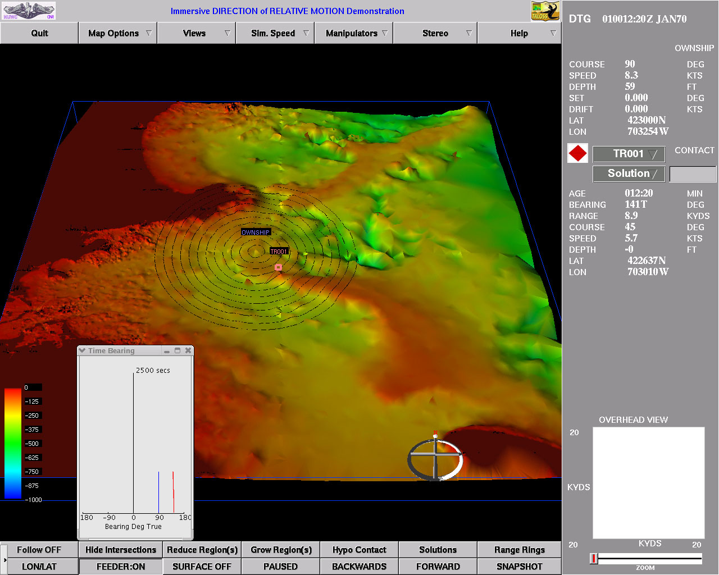
Figure 2.1.4 DGL based TALOSS on Linux desktop computer.

Advances in three dimensional (3D) presentation tools coupled with the continuing increases in computer power make the use of 3D visualization techniques to alleviate the mental information processing issues achievable. Computers today possess a greater capacity to support the modeling and processing of the types of complex information that the undersea environment requires. The combination of 3D visualization software and current/future computational resources provides the opportunity to generate detailed acoustic and environmental models and enables the depiction of the undersea domain in a manner that is more natural and robust than ever before. High-speed computers make it possible to include discrete simulation models of tactical systems as well as physically realistic simulation models of other mission critical C&C activities such as underwater acoustic phenomena related to undersea warfare.

In fleet systems today, Target Motion Analysis (TMA) operators view only a depth slice of the ideal conical angle. Target localization is manually (operator) intensive. Probabilistic estimators are not generally invoked, as the scenarios do not often lend themselves to an observable solution. The operator spends valuable time trying to determine the best solution.

TALOSS is a joint project coordinated by NUWC with NRL and Virginia Tech's UVAG group and funded by ONR NAVCIITI Task2.1a. It addresses the problem of visualizing the 3D nature of measurements received from a submarine towed line array and comprises three main areas of research in the context of a submarine Anti-Submarine Warfare (ASW) mission. The first area of research pertains to the design and development of algorithms that model the undersea environment and ship kinematics. The second area of research focuses on the identification, implementation, and validation of data representation techniques. The last area of research focuses on the development of principles for guiding 3D development for undersea information and on the 'value added' in the use of 3D techniques.

The TALOSS Project has two branches: The first branch involves trying to improve the current system used in the submarines, by designing a 3D visualization interface that can be effectively used with a monitor screen, with the input devices normally found on a submarine (keyboard and trackball). The second branch tries to find which tactical scenarios are best described in a 3D display, like CAVE or I-Desk, cut due to space limitations are not feasible for use on board submarines.

The success of the TALOSS project from NUWC’s viewpoint motivated NUWC to submit this project for consideration as a Future Naval Capabilities (FNC) project, but due to budget cuts the Office of Naval Research (ONR) did not fund TALOSS as an FNC project. Recently SGI has ported Performer to run on both Microsoft Windows and Linux. SGI is now considering porting Performer to Mac OS-X Panther. If SGI successfully ports Performer to Windows and Mac OS-X, the NUWC can port the existing Performer based and OpenGL based TALOSS code in the future when funding becomes available. As a future benefit to the Navy, Performer, Inventor, and OpenGL based TALOSS code have been archived and made accessible from the NAVCIITI Task 2.1 Web site. This same Web site with archived code downloads has been archived on Compact Disks (CD) and will be distributed to NUWC and others interested upon request. DIVERSE and all derivative software and applications are licensed “open-source” (GPL/LGPL)

2.1.2 Facilities Developed for Task 2.1

2.1.2.1 The existing NSF CAVE Virtual Environment (VE) system was moved and upgraded
Existing CAVE and I-Desk VE systems were used extensively for the NAVCIITI project. The existing CAVE VE system was funded at $890,000 by the NSF Academic Research Infrastructure (ARI) program, Dr. Ronald Kriz PI, with $650,000 in cost sharing matching funds from Virginia Tech, that were exclusively used to purchase the equipment to build the CAVE VE system at the Virginia Tech Corporate Research Corporation (off-campus) while the Advanced Communication and Information Technology Center (ACITIC) was under construction on campus. The NSF-ARI proposal outlined how Virginia Tech in partnership with the NSF National Center for Supercomputing Applications (NCSA) would support and include the CAVE as part of the ACTIC building, now called Torgersen Hall, which would be supported as a multidisciplinary resource on campus. Five colleges contributed over $300,000 in cost sharing funds with 30 proposal CoPIs from four colleges. Prior to any of the ONR grants, Dr. Kriz worked with the university architects, as director of the University Visualization and Animation Group (UVAG) to create a unique space in the ACITC building that would realize future uses of the CAVE VE system, e.g. an open pit in the floor of the CAVE was designed to include a glass floor with a projection system below the CAVE floor and extra ceiling height was constructed above the CAVE with a ceiling projection system as well. Hence the ACITC building was designed to provide a working space for a six-sided fully enclosed CAVE VE projection system.

Since there was no returned overhead associated with the NSF-ARI grant, Virginia Tech sought new proposals that would provide funds to move and upgrade the existing NSF CAVE VE system. Three ONR grants provided the necessary funds: MURI, DURIP, and NAVCIITI. The ONR MURI/DURIP Virtual Craneship grants, Professor Ali Nayfeh PI, provided funds that were used to move and upgrade the CAVE into the ACTIC building (Torgersen Hall) by constructing a six-degree (6-DOF) of freedom motion platform in the floor of the CAVE. There were insufficient funds to build a six-sided CAVE with a ceiling and glass floor projection system -- only a motion platform was created in the floor of the existing NSF CAVE VE system. With First year NAVCIITI funds, Professor Ali Nayfeh NAVCIITI-CoPI, were used to upgrade the NSF CAVE tracking system with an Intersense IS-900 and a SGI-Cirrus video capability with audio serial option for controlling the various I/O devices related to the motion platform in the floor of the CAVE. After year one NAVCIITI funds, Dr. Ronald Kriz NAVCIITI-CoPI, were used to provide maintenance on the existing upgraded NSF CAVE VE system. The overlap between NSF and ONR CAVE related grants was coordinated by Dr. Ronald Kriz, Director of the University Visualization and Animation Group of the ACITC, who supervised the construction of the motion platform in the floor of the CAVE in the ACITC building on campus. Dr. Lance Arsenault, who was working for Caterpillar Inc. at NCSA’s CAVE, was hired by Professor Nayfeh to build motion platform hardware system for the ONR MURI/DURIP Virtual Craneship project, similar to those built for Caterpillar at NCSA’s CAVE. The reader is referred to Professor Nayfeh’s NAVCIITI report for accomplishments and costs associated with the Virtual Craneship project. Two documents associated with the construction of the motion platform in the CAVE floor can be accessed at the NAVCIITI Task 2.1 Web site: 1) Chronology of CAVE Floor Construction in ACITC (Torgersen Hall), and 2) Timeline on the CAVE Floor 6-DOF Motion Platform Construction. The construction of a motion platform in the floor of the CAVE at Virginia Tech represents a significant effort and unique resource for future Navy research projects that will be facilitated under the Virginia Tech ICTAS initiative as previously described.

2.1.2.2 DIVERSE VE API
Unique to the motion platform embedded in the CAVE VE system was an Application Programming Interface (API) called DIVERSE that would facilitate the development of VE applications in the CAVE. Unlike previous CAVE VE systems the UVAG CAVE VE system required coordination of a variety of I/O devices: 1) 6-DOF motion tracking system for both the CAVE user’s head and hand, 2) 6-DOF motion platform embedded in the CAVE floor, and 3) future hand held I/O devices such as 6-DOF haptic force feed-back systems and pocket PCs anticipated as future command and control devices for task 2.1. Dr. Arsenault conducted a survey of current VE software systems and concluded that there was no existing VE API that could handle the multiple I/O devices needed for the ONR Virtual Craneship project. With second year NAVCIITI Task 2.1 funds, Dr. Ronald Kriz NAVCIITI-CoPI, the DIVERSE (Device Independent Virtual Environment: Reconfigurable, Scalable, and Extensible) API was created both for the Virtual Craneship and Task 2.1. Dr. Lance Arsenault developed the DIVERSE ToolKit (DTK), which was used to “glue” the various I/O devices used in the upgraded NSF CAVE VE system with the motion platform and Mr. John Kelso developed the DIVERSE interface to Performer (DPF) that was used to create three-dimensional (3D) scenegraphs, which were controlled by various DTK I/O devices. Together DPF and DTK were used for a variety of NSF and ONR VE projects. Several other companies, Lockheed Martin Astronautics, TASC’s IT Division of Northrup Gruman, and the National Institute for Standards and Technology (NIST-Dept. of Commerce) were also interested in using DIVERSE DTK and DPF and co-funded the development of DIVERSE VE API. Hence the DIVERSE API was licensed under the GNU Public License (GPL) as a shared “open-source” resource for all participants. DIVERSE can be accessed at the Sourceforge Web site: http://diverse.sourceforge.net. DIVERSE related applications can be accessed at the NAVCIITI Task 2.1 Web site: http://www.sv.vt.edu/future/cave/resprj/navciiti/nuwc_task2-1/task2-1.html.

2.1.3 Accomplishments

2.1.3.1 Collaborative CAVE Console (CCC): based on the CAVE-library API
In the first year we developed a networked collaborative Virtual Environment (VE) application called the Collaborative CAVE Console (CCC), which was based on the University of Illinois VE API called the CAVE-Library and the Electronic Visualization Laboratory (EVL) networked VE application called LIMBO. The CCC VE application was working prototype that provided a basis for creating future networked tactical interfaces: http://www.sv.vt.edu/future/cave/software/ccc/

2.1.3.2 Atomview and CCC_atom
In the first year the CCC was combined with the existing Performer based application called Atomview to demonstrate how existing VE CAVE applications could be extended as a network collaborative application called CCC_atom: http://www.sv.vt.edu/future/cave/software/cccatom/.

2.1.3.3 CAVE motion platform construction
The construction of the motion platform was funded by ONR MURI/DURIP grant, Professor Ali Nayfeh PI, built by Dr. Lance Arsenault and coordinated by Dr. Ronald Kriz, as Director of the University Visualization and Animation Group (UVAG) and PI on the NSF ARI Grant. The motion platform was an addition to the existing NSF ARI CAVE grant. Accomplishments are summarized in two documents which can be accessed at the NAVCIITI Task 2.1 Web site: 1) Chronology of CAVE Floor Construction in ACITC (Torgersen Hall), and 2) Timeline on the CAVE Floor 6-DOF Motion Platform Construction.

2.1.3.4 The DIVERSE VE API supports both Performer-based and OpenGL-based versions
The DIVERSE VE API under went several revisions as reflected in the original Web site, http://www.diverse.vt.edu/old_index.html which was Performer-based, as well as the recent OpenGL-based Sourceforge Web site: http://diverse.sourceforge.net. Both are “open-source” Web sites.

2.1.3.5 TALOSS
Several versions of TALOSS where created as the project with NRL and NUWC evolved. The current DGL version of TALOSS is documented and can be downloaded from the NAVCIITI Task 2.1 Web site: http://www.sv.vt.edu/future/cave/resprj/navciiti/nuwc_task2-1/task2-1.html.

2.1.3.6 DIVERSE Adaptable Display System (DADS) Linux VE computer system.
The Linux DADS system is a well documented DIVERSE application, that was designed to be adapted to future VE projection systems, e.g. tiled walls. Currently the DADS system at Virginia Tech is used to control the CAVE projection system. Performer-based DIVERSE applications will run on the Linux DADS system and are fully backward compatible with previous legacy Performer-based code that ran on the SGI Irix computer. All the Performer programmer needs to do is load a new DADS DSO with legacy Performer code. Detailed information about the DADS computer system is available both on the DIVERSE Sourceforge and the NAVCIITI Task 2.1 Web sites. PNY Technologies recognized DADS on their case study Web site: http://www.pny.com/pressroom/caseStudies/vc.asp.

2.1.3.7 OpenGL DIVERSE interface to Performer (DPFGL)
A new OpenGL interface to Performer (DPFGL) was created that will allow OpenGL programmers to run their OpenGL legacy code on the new Performer-based DADS Linux computer system. This is as simple as change the GLUT interface to the DPFGL interface. This interface is relatively new, as is the DADS system. Preliminary results show that an experienced OpenGL programmer, who was using the Kitware Inc. Visualization ToolKit (VTK), experienced little difficulty running legacy OpenGL VTK code on the new Linux DADS VE CAVE system. DPFGL can be downloaded from the DIVERSE Sourceforge Web site.

2.1.3.8 DADS motion platform
This was largely motivated by the fact that the SGI Power Onyx CAVE computer system was eight years old and would most likely no longer be supported by SGI. Since the motion platform in the floor of the CAVE is currently controlled through an RS-422 port on the SGI CAVE computer, the DADS Linux system was upgraded with an RS-422 card and the old DTK 2.1 moog code was modified to run on DTK 2.3.2 on the DADS system. A DADS motion platform user’s guide with simple examples will be posted on the NAVCIITI Task 2.1 Web site which will provide continuity for future Navy projects that will inevitably have to use the motion platform on the new DADS Linux computer system when the Virginia Tech SGI CAVE computer system becomes obsolete.

2.1.4 Importance of the Task

The work performed for the NUWC-POC resulted in a proposed Future Navy Capability (FNC). As evidence, an unsolicited letter from NUWC is copied below in italics.

“ The work performed at VT under the NAVCIITI project has had an invaluable impact on the Navy's initiatives to assess virtual reality technology within the context of warfighter needs. These needs include tactical, training, and planning operations. VT has developed a unique application tool called DIVERSE which provides a versatile backbone for combining a broad spectrum of applications and interface devices, and will soon be extended to an Open GL version, which will allow the software to run on a broad spectrum of machines from UNIX to SG to LINUX PCs. This will facilitate the Navy's ability to get VR programs and devices operational on shipboard and submarine systems quickly. A specific beneficiary of the work conducted under NAVCIITI funding is a program entitled "Visualization for Multiwarfare Planning and Execution" - an Office of Naval Research (ONR) funded effort led by the Naval Undersea Warfare Center and the Naval Research Laboratory. This project rated as ONR's best C4I project at their May 2001 review, specifically addresses the "value added" of 3D visualization and VR in the context of the submarine passive localization problem. In FY03 this program will evolve into a Future Naval Capabilities (FNC) effort aimed at developing a 3D VR-based sensor-to-shooter decision aid for submarines. Without the support of VT and specifically the NAVCIITI project, which laid the necessary groundwork and developed the necessary expertise at VT, this project would neither have evolved as quickly as it has and would not have had the tool (DIVERSE) we are using to assess VR options or to integrate VR technology into the current UNIX-based Navy submarine combat system (Open GL DIVERSE). VT has done an excellent job under NAVCIITI support in furthering the state of the art in virtual reality, has developed an outstanding VR tool in DIVERSE and has developed outstanding scientists who have made significant contributions to Navy programs.”

Kenneth Lima (Principle Investigator) and Richard Shell (Technical Lead Engineer) at the Naval Undersea Warfare Center, Newport, RI -“Visualization for Multiwarfare Planning and Execution”.

2.1.5 Productivity Summary

NAVCIITI PRODUCTIVITY FOR 1998 – 2004
Task 2.1 Command and Control Visualization

1. JOURNAL PUBLICATIONS

- J.T. Kelso, S.G. Satterfield, L. E. Arsenault, P.M. Ketchan, R.D. Kriz, "DIVERSE: A Framework for Building Extensible and Reconfigurable Device-Independent Virtual Environments and Distributed Asynchronous Simulations", Presence, Vol. 12, pp. 19-36, 2003.

- Churcher, N. , Irwin, W., and Kriz. R., “Visualising class cohesion with virtual worlds”, Conferences in Research and Practice in Information Technology Series, Proceedings of the Australian symposium on Information visualization, Adelaide, Australia, Vol. 24, pp. 89–97, 2003.

2. CONFERENCE PRESENTATIONS

- J.T. Kelso, L.E. Arsenault, R.D. Kriz, R.D., and F. Das-Neves, “DIVERSE: a Software Toolkit to Integrate Distributed Simulations and Heterogeneous Virtual Environments”, Joint Aerospace Weapon Systems: Support, Sensors, and Simulations Symposium Exhibition, San Diego, CA, July 22-27, 2001.

- R.D. Kriz, F. Das-Neves, and J.T. Kelso, “Virtual and Collaborative Design Environments,” ONR Undersea Weapon Simulation Based Design Workshop, College Park, MD, June 13-15, 2001.

- A. Nayfeh, L. Arsenault, D. Mook, and R. Kriz, “Virtual Environment for Ships and Ship-Mounted Cranes,” ONR Undersea Weapon Simulation Based Design Workshop, College Park, MD, June 13-15, 2001.

- A. Nayfeh, L. Arsenault, D. Mook, and R. Kriz, “Virtual Environment for Ships and Ship-Mounted Cranes,” Undersea Weapon Simulation Based Design Workshop, Newport, RI, June 7-9, 2000.

3. BOOKS AND BOOK CHAPTERS

4. PATENTS, SOFTWARE, ETC

Software (all software licensed GPL/LGPL)
- DIVERSE: http://diverse.sourceforge.net
- Collaborative Toolkit for DIVERSE: http://www.sv.vt.edu/future/cave/software/D_collabtools/D_collabtools.html
- X-Wand: http://www.sv.vt.edu/future/cave/software/D_XWand/D_XWand.html
- D_Atomview: http://www.sv.vt.edu/future/cave/software/D_atomview/D_atomview.html

5. HONORS AND RECOGNITIONS

- Keynote Speaker along with Dr. Lance Arsenault and Mr. John Kelso at the ONR Undersea Weapon Simulation Based Design Workshop, “Virtual and Collaborative Design Environments”, College Park, MD, June 13-15, 2001.

6. STUDENTS COMPLETED

Master of Science

- Gregory Edwards, “Performance and Usability of Force Feedback and Auditory Substitutions in a Virtual Environment Manipulation Task”, Chair Woodrow Barfield, ISE, November 2000.

- Avdrew Ray, “A Metrics Study in Virtual Reality”, Co-chair: S. Henry, C.S. and R.D. Kriz, ESM, May 2004.

7. STUDENTS SUPPORTED

- Greg Edwards, ISE, 1999-2000
- Fernando das Neves, CS, 1999-2003
- Andrew Ray, CS, 2003-2004

8. FACULTY SUPPORTED

- Lance Arsenault, Assistant Research Professor, CS, 1999-2001
- John Kelso, Assistant Research Professor, CS, 1998-2003

9. OTHER PERSONNEL SUPPORTED

Undergraduate Research Assistants
- Andrew Ray, 2001-2003
- Daniel Larimer, summer 2004

